FAT00100 – FA Acquisition

PROGRAM DEFINITION
- Program to add, update, submit, approve, commit, view, cancel, and other managing of asset acquisition activities

ROLES
Test
- Program Ran by user who have right to access the program

RELATED TABLES
Table | Access
- FAT_TRANS_HD  - FAT_TRANS_ASSET  - FAT_TRANS_EXP_ALLOC  - FAM_ASSET  - FAT_TRANS_JRN  - GSM_TRANSACTION_NUMBER  - FAM_ASSET_NUMBER  - FAM_SYSTEM  - HSM_PROPERTY_SYSTEM  - GSM_TRANSACTION_CODE  - GSM_SUPPLIER  - GSM_SUPPLIER_INFO  - GSM_DEPARTMENT  - GSX_DEPARTMENT_USER  - GSM_PERIOD  - GSM_PERIOD_DT  - SAB_CURRENCY  - GSB_TRANSLATE  - GSB_CODE_DT  - FAM_APPROVAL_USER  - GSM_USER_RIGHT  - GSM_ACTIVITY_APPROVAL | R/W  R/W  R/W  R/W  R/W (via SP)  R/W (via SP)  R/W (via SP)  R  R  R  R  R/W  R  R  R  R  R  R  R  R  R  R

Form 1 Page 1 : FA Acquisition – Acquisition Entry – Source=FA
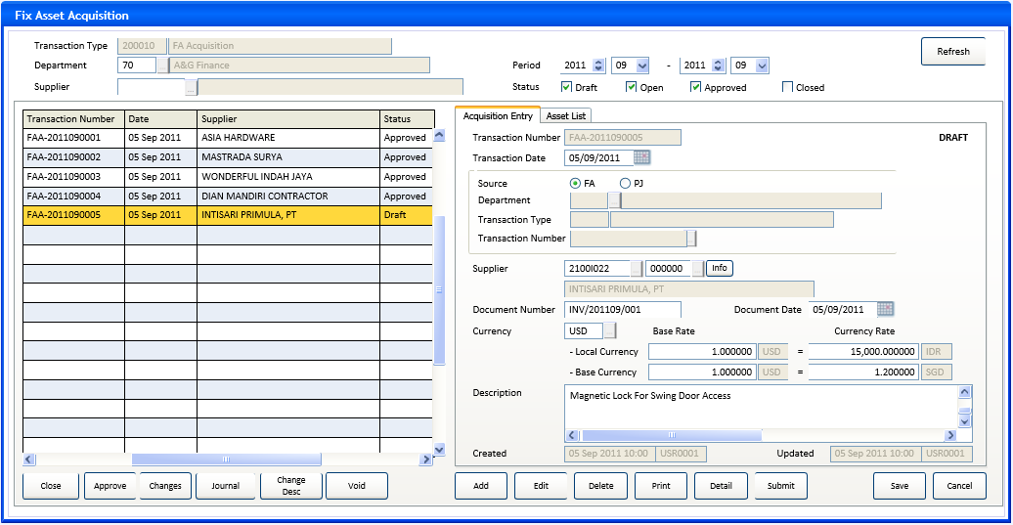
Form 1 Page 1 : FA Acquisition – Acquisition Entry – Source=PJ
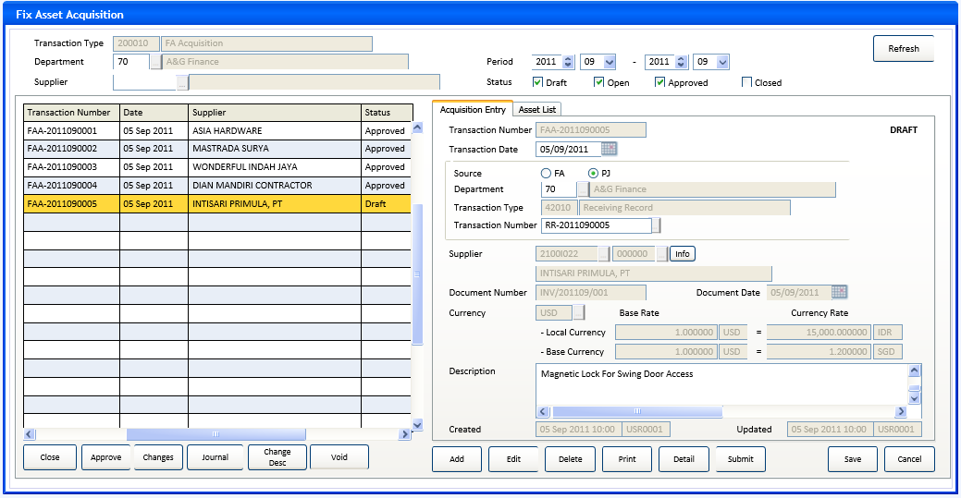

Form 1 Page 1 : FA Acquisition - Acquisition Entry – change description
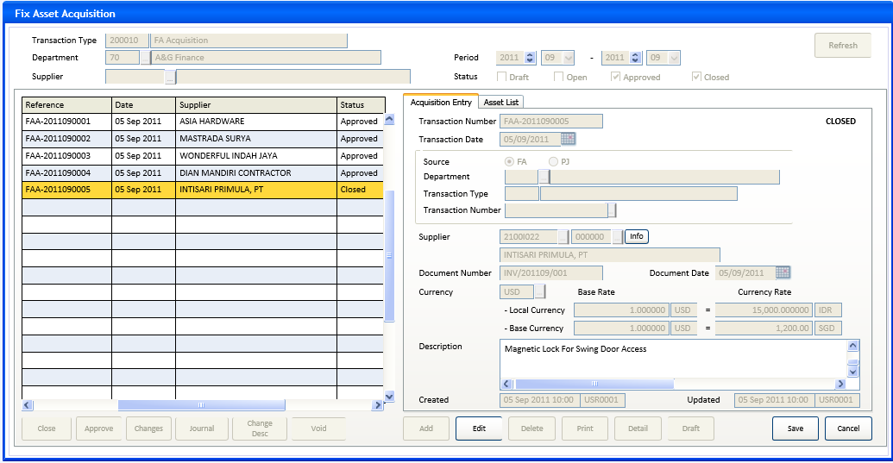

Form 1 Page 2 : FA Acquisition - Asset List
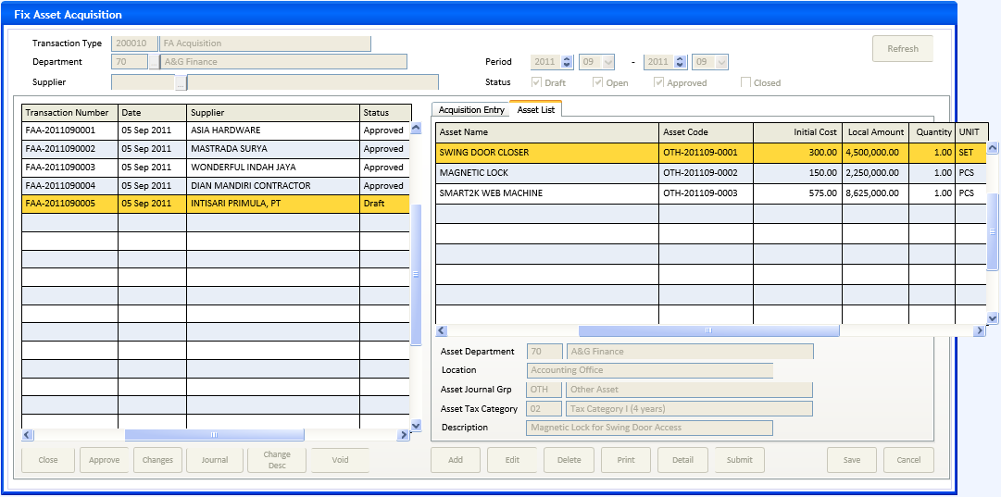

INITIAL PROCESS
Form 1 – FA Acquisition
- Parameter from calling program: @PCMODE, @PCDEPT_CODE, @PCREFERENCE_NO
- Get FA Period and other parameters from FA System table
SELECT @CDEFAULT_TRX_DEPT_CODE = CTRANS_DEPT_CODE,
@CDEFAULT_ASSET_DEPT_CODE = CASSET_DEPT_CODE,
@LASSET_INCREMENT_FLAG = LINCREMENT_FLAG, @LJRNGRP_MODE = LJRNGRP_MODE, @LDEPT_MODE = LDEPT_MODE,
@CPERIOD_MODE = CPERIOD_MODE, @CCURRENT_PERIOD = CCURRENT_PERIOD, @CSOFT_PERIOD = CSOFT_PERIOD,
@CRATETYPE_CODE = CRATETYPE_CODE,
@CGLLINK_DATE=CGLLINK_DATE, @CPJLINK_DATE=CPJLINK_DATE
FROM FAM_SYSTEM (nolock)
WHERE CCOMPANY_ID={login_company_id}
- @CFILTER_TRANS_CODE = ’200010’
@CFILTER_DEPT_CODE = if @PCDEPT_CODE<>’’ then @PCDEPT_CODE else @CDEFAULT_TRX_DEPT_CODE
@CFILTER_SUPPLIER_ID = ’’
@PCMODE = if @PCMODE = ’’ then ’T’ run from menu will be Transaction mode
- If @PCREFERENCE_NO <> ’’
SELECT @CFILTER_SUPPLIER_ID = CSUPPLIER_ID,
@CTRANSACTION_PRD = CTRANSACTION_PRD
From FAT_TRANS_HD (nolock)
Where CCOMPANY_ID={login_company_id} AND CTRANSACTION_CODE=@CFILTER_TRANS_CODE and CDEPT_CODE =
@PCDEPT_CODE and CREFERENCE_NO = @PCREFERENCE_NO
- Get Local and Base Currency

SELECT @CLOCAL_CURRENCY_CODE = CLOCAL_CURRENCY_CODE,
@CBASE_CURRENCY_CODE = CBASE_CURRENCY_CODE,
@LCUST_PERIOD_FLAG = LCUST_PERIOD_FLAG
FROM HSM_PROPERTY_SYSTEM (nolock)
WHERE CCOMPANY_ID={login_company_id}
- Get FA Transaction Type description, approval flag, and numbering setting (manual or auto increment)
SELECT @CFILTER_TRANS_DESC = ISNULL(b.CDESCRIPTION,a.CTRANSACTION_NAME),
@LTRANS_APPROVAL = LAPPROVAL_FLAG,
@LINCREMENT_FLAG = LINCREMENT_FLAG
From GSM_TRANSACTION_CODE a (nolock)
LEFT JOIN GSB_TRANSLATE b (nolock) ON b.CTABLE_NAME =’GSM_TRANSACTION_CODE’ AND
B.CFOREIGN_LANGUAGE={login_user_Lang_id} AND B.CKEY_ID=a.CCOMPANY_ID + a.CTRANSACTION_CODE
Where a.CCOMPANY_ID={login_company_id} AND CTRANSACTION_CODE=@CFILTER_TRANS_CODE
- Get PJ Transaction Type (RR) description
@CPJ_TRANS_CODE = ’420010’
SELECT @CPJ_TRANS_DESC=ISNULL(b.CDESCRIPTION,a.CTRANSACTION_NAME)
From GSM_TRANSACTION_CODE a (nolock)
LEFT JOIN GSB_TRANSLATE b (nolock) ON
b.CTABLE_NAME =’GSM_TRANSACTION_CODE’ AND B.CFOREIGN_LANGUAGE={login_user_Lang_id}
AND B.CKEY_ID=a.CCOMPANY_ID + a.CTRANSACTION_CODE
Where a.CCOMPANY_ID={login_company_id} AND CTRANSACTION_CODE=@CPJ_TRANS_CODE
- Get user right for approval :
@LCAN_APPROVE = 0
SELECT @LCAN_APPROVE = 1
FROM FAM_APPROVAL_USER (nolock)
WHERE CCOMPANY_ID={login_company_id} AND CTRANSACTION_CODE==@CFILTER_TRANS_CODE AND
CUSER_ID={login_user_Id}
- Preparation for spinner Period year from/to :
If @PCREFERENCE_NO<>’’
then Set value range only 1 value = CONVERT(SMALLINT,LEFT(@CTRANSACTION_PRD,4))
else
SELECT @ISTART_YEAR=CONVERT(SMALLINT,MIN(CCYEAR)),
@IEND_YEAR=CONVERT(SMALLINT,MAX(CCYEAR))
From GSM_PERIOD (nolock)
Where CCOMPANY_ID={login_company_id}
Set value range between @ISTART_YEAR and @IEND_YEAR
Set Default Value = CONVERT(SMALLINT,LEFT(@CSOFT_PERIOD,4))
- Preparation for combobox Period month from/to :
If @PCREFERENCE_NO<>’’
then Set value list only 1 value = RIGHT(@CTRANSACTION_PRD,2)
else Set value list :
SELECT CPERIOD_NO
From GSM_PERIOD_DT (nolock)
Where CCOMPANY_ID={login_company_id} AND CCYEAR=LEFT(@CSOFT_PERIOD,4)
Set Default Value = RIGHT(@CSOFT_PERIOD,2)
- Get User Activity Rights :
SET @LCAN_CLOSE=0
SELECT @LCAN_CLOSE=1
FROM GSM_USER_RIGHT (nolock)
WHERE CCOMPANY_ID={login_company_id} AND CACTIVITY_CODE=’FA013001’ AND CUSER_ID={login_user_id}

- Create empty temporary table #OneTimeSupp and #OneTimeCP :
SELECT * INTO #OneTimeSupp FROM GSM_SUPPLIER_INFO WHERE 1=0
SELECT * INTO #OneTimeCP FROM GSM_SUPPLIER_CONTACT WHERE 1=0

- Set @LCHANGE_DESC = 0
- Set default value of header filter fields. (see Field Definition)
- Do Refresh button click to refresh grid’s and form’s data fields
- Go into Normal mode

BUTTON DEFINITION
Form 1 - FA Acquisition | Test
- Refresh
- Enabled in Normal mode when @PCREFERENCE_NO=’’
- Validate : {Department} is not empty Message : Please enter a valid Department code
- Validate : {Period from} <= {Period to} Message : Please enter a valid Period from-to
- Validate : at least 1 of Status checboxes is checked Message : Please select at least one of transaction status
- Run query to fill the grid based on filter fields.
- Change active (current) page to Acquisition Entry page
- Refresh form page’s data fields to match to current record of the grid.
- Lookup Department (at header filter)
- Run Prog GSL00500, with parameter {login_company_id}, {login_user_lang_id}, 1
- Return value to Department code and description (at header filter)
- Enabled in Normal mode when @PCREFERENCE_NO=’’

- Lookup Supplier (at header filter)
- Run Prog GSL04200 with parameter {login_company_id}
- Return value to Supplier code and name (at header filter)
- Enabled in Normal mode when @PCREFERENCE_NO=’’
- Lookup Department(at entry page)
- Run Prog GSL00500, with parameter {login_company_id}, {login_user_lang_id}, 1
- Return value to Department code and description (at entry page)
- Enabled in Add mode or Edit mode when @LCHANGE_DESC=0 and {Source} = PJ
- Lookup Transaction Number
- Run Prog FAL01100 Lookup Receiving Record, with parameter {login_company_id}, {Department code}, ’420010’, {Supplier code}, {Transaction date}, {login_user_lang_id} --CR1
- Return value to Transaction Number then do its lost focus
- Enabled in Add mode or Edit mode when @LCHANGE_DESC=0 and {Source} = PJ and {Department code}<>’’ and {Transaction Date}<>’’

- Lookup Supplier (at entry page)
- Run Prog GSL04200 with parameter {login_company_id}
- Return value to Supplier code and name (at entry page)
- Enabled on Add mode or edit mode when {Source} = FA and @LCHANGE_DESC=0

- Lookup Supplier sequence (for one time supplier)
- Run Prog GSL04210, with parameter {login_company_id}, {Supplier code}
- Return value to Supplier sequence number
- Hidden when @LONETIME=0
- Enable on Add mode or edit mode when {Source} = FA and @LCHANGE_DESC=0

- Info (for One Time Supplier)
- Run Prog APT00010, with parameter : table #OneTimeSupp, table #OneTimeCP, 1
- Hidden when @LONETIME=0
- Enable on Add or Edit mode when {Source} = FA and @LCHANGE_DESC=0
- Lookup Currency
- Run Prog HSL51200 with no parameter
- Return value to Currency code
- Enabled on Add mode or edit mode when {Source} = FA and @LCHANGE_DESC=0

- Add
- Enabled on Normal mode when @PCMODE = ’T’, depend on user access right for Add
- Enable-disable input fields in the input form (see Display Process)
- Enable-disable buttons in the input form (see Button Definition)
- Disable all input fields and buttons outside the input form, except for Save and Cancel button should be enabled
- Enter to Add mode
- Edit
- Enabled on Normal mode when @PCMODE = ’T’ and CSTATUS=’00’ and depend on user access right for Edit
- Validate no asset made for this transaction not found in this query :
Select CASSET_CODE
From FAT_TRANS_ASSET (nolock)
where CCOMPANY_ID={login_company_id} AND DEPT_CODE={filter Department code} AND
CTRANSACTION_CODE={filter Transaction Type} and CREFERENCE_NO={header Transaction
Number} and LDELETE_FLAG=0
Message : Can not modify transaction already has detail asset

- Enable-disable input fields in the input form (see Display Process)
- Enable-disable button in the input form (see Button Definition)
- Disable all input fields and button outside the input form, except for Save and Cancel button should be enabled
- Enter to Edit mode

- Delete
- Enabled on Normal mode when @PCMODE=’T’ and CSTATUS=’00’ or ’01’ and depend on user access right for Delete --CR11
- Confirmation : ’You can not undo delete. Are you sure to delete this transaction ?’ (Yes/No)
- If ‘Yes’ then do RSP_FAT_DELETE with parameters : {login_company_id},{filter Department code}, {filter Transaction Type}, {header Transaction Number}
- Back to form and refresh

- Print
- Enabled on Normal mode when any active data and depend on user access right for printing
- Run FAR00010 Print FA Transaction to print current data with parameter {login_company_id}, {CDEPT_CODE}, {@CFILTER_TRANS_CODE}, {CREFERENCE_NO}, {login_user_id}, {login_language_ID}
- Detail
- Enabled on Normal mode
- Run form 2 with parameter : @PCDEPT_CODE=CDEPT_CODE, @PCREFERENCE_NO=CREFERENCE_NO
- Draft/Submit
- Enabled on Normal mode when @PCMODE = ’T’ and (CSTATUS IN(’00’,’01’) or (CSTATUS=’03’ and @LTRANS_APPROVAL = 0)), and depend on user access right for edit
- If CSTATUS=’00’ then caption = ’Submit’ else ’Draft’
- If CSTATUS=’00’ then validate found in this query : --CR10
Select TOP 1 CASSET_CODE
From FAT_TRANS_ASSET (nolock)
where CCOMPANY_ID={login_company_id} AND DEPT_CODE={filter Department code} AND
CTRANSACTION_CODE={filter Transaction Type} and CREFERENCE_NO={header Transaction
Number} and LDELETE_FLAG=0
Message : Can not submit transaction without asset made for

- If CSTATUS=’00’ then confirm : ’Are you sure to change to submit for this transaction ?’
else confirm : ’Are you sure to change to draft for this transaction ?’
(Yes/No)
- If ’Yes’ then do RSP_FAT_SUBMIT with parameters : {login_company_id}, {filter Department code}, {filter Transaction Type}, {header Transaction Number}
- Back to form and refresh
- Save
- Enabled on Add or Edit mode
- Do VALIDATE TRANSACTION, if not valid then back to form
- Do SAVE TRANSACTION
- Do SAVE GSM_SUPPLIER_INFO
- Back to Normal mode

- Cancel
- Enabled on Add or Edit mode
- Cancel data input and restore field’s value
- Back to normal mode

- Close
- Enable on normal mode when @PCMODE = ’T’, @LCAN_CLOSE=1 AND (CSTATUS=’03’ or (CSTATUS=’01’ AND @LTRANS_APPROVAL=0))
- Validate GL Accounts available : --CR11
Do RSP_FA_VALIDATE_JOURNAL with parameters : {login_company_id}, {filter Department code}, {filter Transaction Type}, {header Transaction Number}
Message : GL account for journal is not available
- Confirmation : ’Please be aware, you can not modify this transaction anymore after this process’ (Process/Cancel)
- If ’Process’ then do RSP_FAT_CLOSE with parameters : {login_company_id}, {filter Department code}, {filter Transaction Type}, {header Transaction Number}
- Back to form and refresh
- Approve
- Enabled when @PCMODE = ’T’ and CSTATUS IN(’01’,’02’) and @LTRANS_APPROVAL=1 and @LCAN_APPROVE=1
- Do RSP_FAT_APPROVE with parameters : {login_company_id}, {filter Department code}, {filter Transaction Type}, {header Transaction Number}
- Refresh grid list
- Void
- Enabled on Normal mode when @PCMODE=’T’ and CSTATUS=’08’ and CTRANSACTION_PRD >= @CSOFT_PERIOD and (LGLLINK=0 or CGL_TRF_STATUS = ’0’) --CR19
- Validate all the assets have no next transaction should be not found in :
SELECT CASSET_CODE
FROM FAT_TRANS_ASSET a (nolock), FAM_ASSET b (nolock)
WHERE a.CCOMPANY_ID={login_company_id} AND a.CDEPT_CODE={grid.CDEPT_CODE} AND
a.CTRANSACTION_CODE=@CFILTER_TRANS_CODE and a.CREFERENCE_NO={grid.CREFERENCE_NO} and
LDELETE_FLAG=0 and b.CCOMPANY_ID=a.CCOMPANY_ID and b.CASSET_CODE=a.CASSET_CODE and
b.CLSEQUENCE_NO > a.CASSET_TRANS_SEQNO
Message : Can not cancel transaction of asset already has the next one.
- Do FAT02100 with parameter : {login_company_id}, ’1201’, {login_language_id} --CR1
Save return value to @CCANCEL_REASON_CODE varchar(8)
If @CCANCEL_REASON_CODE=’’ then back to form
- Do APPROVAL_PRECHECK parameter ’FA013002’
If returned 1 (need approval)
then Do GST01100 (Approval) with parameter {login_company_id}, ’FA013002’
Save return value to @CCANCEL_APPROVED_BY varchar(8) --CR1
If @CCANCEL_APPROVED_BY=’’ then back to form

- Do RSP_FAT_VOID with parameters : {login_company_id}, {grid.CDEPT_CODE}, @CFILTER_TRANS_CODE, {grid.CREFERENCE_NO}, {login_user_id}, @CCANCEL_REASON_CODE, @CCANCEL_APPROVED_BY --CR1
- Back to form and refresh

- Changes
- Enable on normal mode when there is any active row in grid
- Run GSI00200 with parameter : 1, {login_company_id}, ’FAT00100’, ’FAT_TRANS_HD’
- Journal
- Enable on normal mode when CSTATUS = ’08’
- Run program FAI00020 (FA Transaction Journal) with parameter : {login_company_id}, {grid.CDEPT_CODE}, @CFILTER_TRANS_CODE, {grid.CREFERENCE_NO}
- Back to form
- Change Desc
- Enable on normal mode when @PCMODE = ’T’ and CSTATUS not in (’00’,’09’,’98’,’99’) and depend on user access right for Edit
- Enable Description input fields in the input form
- Disable all input fields and button outside the input form, except for Save and Cancel button should be enabled
- Set @LCHANGE_DESC = 1 --CR1
- Enter to Edit mode
- Restore @LCHANGE_DESC = 0 --CR1

OUTPUT
Test
- None

DISPLAY PROCESS
Form 1 - FA Acquisition – header filter
    - FIELD DEFINITION
  - Transaction Type code
    - Field : @PCFILTER_TRANS_CODE varchar(6)
    - Always disabled
    - Default value : see Initial Process
  - Transaction Type description
    - Field : @CFILTER_TRANS_DESC nvarchar(60)
    - Always disabled
    - Default value : see Initial Process
  - Department code
    - Field : @CFILTER_DEPT_CODE varchar(8)
    - Enabled when @PCREFERENCE_NO=’’
    - Default value : see Initial Process
    - Validate not empty
Message : Please enter a Department code
    - Use lookup validation
    - If {lookup.LEVERYONE_FLAG} = 0 then Validate found in :
Select * From GSX_DEPARTMENT_USER (nolock)
Where CCOMPANY_ID = {login_company_id} and CDEPT_CODE={Department code}
AND CUSER_ID = {login_user_id}
Message : You have no rights to access this Department
  - Department name
    - Field : {lookup description} nvarchar(60)
    - Always Disabled
  - Supplier id
    - Field : @CFILTER_SUPPLIER_ID varchar(10)
    - Enabled when @PCREFERENCE_NO=’’
    - Default value : see Initial Process
    - Empty value is allowed, no validation required, set {Supplier name}=’’
    - Use lookup validation
  - Supplier name
    - Field : {lookup description} nvarchar(50)
    - Always Disabled
  - Period from year
    - Field : @CFILTER_PRD_FROM_YEAR varchar(4) CONVERT(VARCHAR(4),{Period from year})
    - Use spinner
    - Enabled when @PCREFERENCE_NO=’’
    - Default value see Initial Process

  - Period from month
    - Field : @CFILTER_PRD_FROM_NO varchar(2) CONVERT(VARCHAR(2),{Period from month}) leading zero, eg : ’01’ , ’02’, …
    - Use combo box, one column
    - Enabled when @PCREFERENCE_NO=’’
    - Default value see Initial Process
  - Period to year
    - Field : @CFILTER_PRD_TO_YEAR varchar(4) CONVERT(VARCHAR(4),{Period to year})
    - Use spinner
    - Enabled when @PCREFERENCE_NO=’’
    - Default value see Initial Process

  - Period from month
    - Field : @CFILTER_PRD_TO_NO varchar(2) CONVERT(VARCHAR(2),{Period to month}) leading zero, eg : ’01’ , ’02’, ’03’, …
    - Use combo box, one column
    - Enabled when @PCREFERENCE_NO=’’
    - Default value see Initial Process
  - Status Draft
    - Field : @LFILTER_DRAFT bit
    - Use checkbox
    - Enabled when @PCREFERENCE_NO=’’
    - Default value = 1 (checked)

  - Status Open
    - Field : @LFILTER_OPEN bit
    - Use checkbox
    - Enabled when @PCREFERENCE_NO=’’
    - Default value = 1 (checked)

  - Status Approved
    - Field : @LFILTER_APPROVED bit
    - Use checkbox
    - Enabled when @PCREFERENCE_NO=’’
    - Default value = 1 (checked)

  - Status Closed
    - Field : @LFILTER_CLOSED bit
    - Use checkbox
    - Enabled when @PCREFERENCE_NO=’’
    - Default value = 0 (unchecked)

Form 1 - FA Acquisition – navigator grid
- Query to fill grid when Refresh buton clicked
SELECT CDEPT_CODE, CREFERENCE_NO, CTRANSACTION_DATE, CSUPPLIER_NAME=ISNULL(b.CSUPPLIER_NAME,’’),
CTRANSACTION_PRD, CSTATUS_DESC=ISNULL(c.DESCRIPTION, a.CSTATUS)
FROM FAT_TRANS_HD a (nolock)
LEFT JOIN GSM_SUPPLIER b(nolock) ON b.CCOMPANY_ID=a.CCOMPANY_ID AND b.CSUPPLIER_ID = a.CSUPPLIER_ID
LEFT JOIN RFT_GET_GSB_CODE_INFO('RHAPSODY', {login_company_id}, ’_TRX_STATUS’, ’’,
{login language id}) c ON c.CODE=a.CSTATUS
WHERE CCOMPANY_ID={login_company_id} AND DEPT_CODE={Department code} AND CTRANSACTION_CODE =
{Transaction Type code} AND ((@PCREFERENCE_NO<>’’ AND CREFERENCE_NO=@PCREFERENCE_NO) OR
(@PCREFERENCE_NO=’’ AND ({Supplier code}=’’ or CSUPPLIER_ID={Supplier code}) AND
CTRANSACTION_PRD BETWEEN {Period from} AND {Period to} AND ((CSTATUS=’00’ AND {Status Draft}=1)
OR (CSTATUS IN(’01’,’02’) AND {Status Open}=1) OR (CSTATUS=’03’ AND {Status Approved}=1) OR
(CSTATUS=’08’ AND {Status Closed}=1))))
- Default display order by CREFERENCE_NO, go top record
- Grid is read only

    - GRID COLUMN DEFINITION, read only
      - Reference
    - Field : CREFERENCE_NO varchar(30)
      - Date
    - Field : CTRANSACTION_DATE char(8) displayed with date format
      - Supplier Name
    - Field : CSUPPLIER_NAME nvarchar(50)

      - Status
    - Field : CSTATUS_DESC nvarchar(20)

Form 1 - FA Acquisition – Acquisition Entry page
    - This entry page contains detail information of current row of navigator grid

- Query to fill entry page fields :
SELECT CDEPT_CODE, CREFERENCE_NO, CSUPPLIER_ID, CINFO_SEQNO, CTRANSACTION_DATE, CTRANSACTION_PRD,
CTRANSACTION_DESCR, CDOCUMENT_DATE, CDOCUMENT_NO, CCURRENCY_CODE, CFR_MODULE, CFR_DEPT_CODE,
CFR_TRANSACTION_CODE, CFR_REFERENCE_NO, NLBASE_RATE_AMOUNT, NLCURRENCY_RATE_AMOUNT,
NBBASE_RATE_AMOUNT, NBCURRENCY_RATE_AMOUNT, CSTATUS, LGLLINK, CGL_TRF_STATUS,
CCREATE_BY, DCREATE_DATE, CUPDATE_BY, DUPDATE_DATE,
CSTATUS_DESC=ISNULL(c.DESCRIPTION, a.CSTATUS)
FROM FAT_TRANS_HD a (nolock)
LEFT JOIN RFT_GET_GSB_CODE_INFO('RHAPSODY', {login_company_id}, ’_TRX_STATUS’, ’’,
{login language id}) c ON c.CODE=a.CSTATUS
WHERE CCOMPANY_ID={login_company_id} AND CDEPT_CODE={grid.CDEPT_CODE} AND CTRANSACTION_CODE =
{Transaction Type code} AND CREFERENCE_NO={grid.CREFERENCE_NO}

    - FIELD DEFINITION
  - Transaction No
    - Field : CREFERENCE_NO varchar(30)
    - Enabled on Add mode when @LINCREMENT_FLAG=0 (manual numbering)
    - If Add mode and not manual numbering, then get CREFERENCE_NO after Save button clicked, then display on this textbox
  - Transaction Date
    - Field : CTRANSACTION_DATE char(8) display in date format
    - Enabled on Add mode or Edit mode and @LCHANGE_DESC=0
    - Default value = {property date}
    - If @LCUST_PERIOD_FLAG = 0
then @CPRD=LEFT({Transaction Date},6)
else SELECT @CPRD=CCYEAR+CPERIOD_NO FROM GSM_PERIOD_DT (nolock)
WHERE CCOMPANY_ID={login CCOMPANY_ID} and {Transaction Date} BETWEEN
CSTART_DATE AND CEND_DATE
    - Validation : @CPRD >= @SOFT_PERIOD
Message : Transaction date should be not less than the soft period
    - Validation : CTRANSACTION_DATE <= {property date}
Message : Transaction date should be not greater than today
    - Validation : Add mode or
@LASSET_INCREMENT_FLAG=0 or
@CPERIOD_MODE=’N’ or
(@CPERIOD_MODE=’P’ and {@CPRD} not changed) or
(@CPERIOD_MODE=’Y’ and LEFT({@CPRD},4) not changed) or
no Asset List data
Message : Can not change Transaction Date causing inconsistent Asset Code
    - Validation : LEFT(@CPRD,4) = LEFT(@CCURRENT_PERIOD,4) --CR4
Message : Transaction date should be in the year of current period
  - Source
    - Field : CFR_MODULE char(2) ’FA’ or ’PJ’ using option button
    - Default : ’FA’
    - Enable on Add mode or Edit mode and @LCHANGE_DESC=0
    - Enable/disable fields : Department code, Transaction Number, Supplier code, Sequence number, Document Number, Document Date, Currency, Base Rate, Currency Rate
    - Enable/disable buttons : Department lookup, Transaction Number lookup, Supplier lookup, Sequence lookup, Info button, Currency lookup
  - (PJ) Department code
    - Field : CFR_DEPT_CODE varchar(8)
    - Enable on Add mode or Edit mode when {Source}=PJ and @LCHANGE_DESC=0
    - Default value : {header filter Department code}
    - Validate not empty
Message : Please enter a Department code
    - Use lookup validation
    - If {lookup.LEVERYONE_FLAG} = 0 then Validate found in :
Select * From GSX_DEPARTMENT_USER (nolock)
Where CCOMPANY_ID = {login_company_id} and CDEPT_CODE={Department code}
AND CUSER_ID = {login_user_id}
Message : You have no rights to access this Department

  - (PJ) Department name
    - Field : {lookup description} nvarchar(60)
    - Always Disabled

  - (PJ) Transaction Type code
    - Field : @CPJ_TRANS_CODE varchar(6)
    - Always disabled

  - (PJ) Transaction Type name
    - Field : @CPJ_TRANS_DESC nvarchar(40)
    - Always disabled
  - (PJ) Transaction Number
    - Field : CFR_REFERENCE_NO varchar(30)
    - Enabled on Add mode or Edit mode when {Source}=PJ and @LCHANGE_DESC=0
    - Use lookup validation
    - Replace and display fields value from lookup output :
{Supplier code} = CSUPPLIER_ID
{Sequence number} = CINFO_SEQNO
{Document Number} = CDOCUMENT_NO
{Document Date} = CDOCUMENT_DATE
{Currency} = CCURRENCY_CODE
{Local Currency} = NLBASE_RATE_AMOUNT, CCURRENCY_CODE, NLCURRENCY_RATE_AMOUNT, @CLOCAL_CURRENCY_CODE
{Base Currency} = NBBASE_RATE_AMOUNT, CCURRENCY_CODE, NBCURRENCY_RATE_AMOUNT, @CBASE_CURRENCY_CODE
  - Supplier code
    - Field : CSUPPLIER_ID varchar(10)
    - Default : @CFILTER_SUPPLIER_ID
    - Enable on Add mode or Edit mode when @LCHANGE_DESC=0 and {Source}=FA
    - Using lookup validation
    - Supplier sequence number, lookup, and button Info are hidden when @LONETIME=0
    - Enable/disable Supplier name
    - If previous value <> current value (value changed)
then DELETE #OneTimeSupp
DELETE #OneTimeCP
Set value of Sequence number = ’’ and refresh
INSERT INTO #OneTimeSupp (CCOMPANY_ID, CSUPPLIER_ID)
VALUES ({login_company_id},{Supplier code})
  - Supplier name
    - Field : CSUPPLIER_NAME nvarchar(60)
Replaced with {lookup.description} when {Supplier code}<>’’
    - Enable on Add mode or Edit mode when @LCHANGE_DESC=0 and {Supplier code}=’’

  - Sequence number (for one time supplier)
    - Field : CINFO_SEQNO char(6)
    - Validate the value is empty or found in :
Select *
From GSM_SUPPLIER_INFO (nolock)
Where CCOMPANY_ID={login_company_id} and CSUPPLIER_ID={Supplier code} and
CINFO_SEQNO={Supplier sequence number}
Message : This one time supplier is not found
    - If previous value <> current value (value changed)
then DELETE #OneTimeSupp
DELETE #OneTimeCP
If current value is empty
then INSERT INTO #OneTimeSupp (CCOMPANY_ID, CSUPPLIER_ID)
VALUES ({login_company_id}, ={Supplier code})
else INSERT INTO #OneTimeSupp
SELECT * FROM GSM_SUPPLIER_INFO (nolock)
WHERE CCOMPANY_ID={login_company_id} and
CSUPPLIER_ID={Supplier code}and
CINFO_SEQNO={One Time Supplier code}
INSERT INTO #OneTimeCP
SELECT * FROM GSM_SUPPLIER_CONTACT (nolock)
WHERE CCOMPANY_ID={login_company_id} and
CSUPPLIER_ID={Supplier code}and
CINFO_SEQNO={One Time Supplier code}

    - Hidden when @LONETIME=0
    - Enabled on Add mode or Edit mode when @LCHANGE_DESC=0 and {Source}=FA
  - Document Number
    - Field : CDOCUMENT_NO nvarchar(20)
    - Enabled on Add or Edit mode when @LCHANGE_DESC=0 and {Source}=FA
  - Document Date
    - Field : CDOCUMENT_DATE char(8) displayed in date format
    - Validation : {Document date} <= {Transaction date}
Message : Document date should not greater than transaction date
    - Enabled on Add or Edit mode when @LCHANGE_DESC=0 and {Source}=FA
  - Currency
    - Field : CCURRENCY_CODE varchar(3)
    - Default value = @CLOCAL_CURRENCY_CODE
    - Enabled on add mode and edit mode when @LCHANGE_DESC=0 and {Source}=FA
    - Synchronize currency code of : Local Currency-Base Rate, Base Currency-Base Rate
    - If user change the Currency :
    - Do RSP_GET_CURRENCY_RATE parameter : {login_company_id}, {Currency}, @CRATETYPE_CODE, {Transaction Date}, @NLBASE_RATE_AMOUNT output, @NBBASE_RATE_AMOUNT output, @NLCURRENCY_RATE_AMOUNT output, @NBCURRENCY_RATE_AMOUNT output
    - Store output variables to field NLBASE_RATE_AMOUNT, NLCURRENCY_RATE_AMOUNT, NBBASE_RATE_AMOUNT and NBCURRENCY_RATE_AMOUNT
    - Set default value for amount of : Local Currency-Base Rate, Local Currency-Currency Rate, Base Currency-Base Rate, Base Currency-Currency Rate
    - If CCURRENCY_CODE = @CLOCAL_CURRENCY_CODE then disable the amount of : Local Currency-Base Rate, Local Currency-Currency Rate
    - If CCURRENCY_CODE = @CBASE_CURRENCY_CODE then disable the amount of : Base Currency-Base Rate, Base Currency-Currency Rate
  - Local Currency - Base Rate - currency code
    - Field : CCURRENCY_CODE varchar(3)
    - Synchronized at Currency lost focus
    - Always disabled

  - Local Currency - Base Rate - amount
    - Field : NLBASE_RATE_AMOUNT numeric 6 decimal, value > 0.000000
    - Synchronized at Currency lost focus
    - Enabled on add mode and edit mode, when @LCHANGE_DESC=0 and {Source}=FA and CCURRENCY_CODE <> @CLOCAL_CURRENCY_CODE

  - Local Currency - Currency Rate - currency code
    - Field : @CLOCAL_CURRENCY_CODE varchar(3)
    - Always disabled

  - Local Currency - Currency Rate - amount
    - Field : NLCURRENCY_RATE_AMOUNT numeric 6 decimal, value > 0.000000
    - Synchronized at Currency lost focus
    - Enabled on add mode and edit mode when @LCHANGE_DESC=0 and {Source}=FA and CCURRENCY_CODE <> @CLOCAL_CURRENCY_CODE

  - Base Currency - Base Rate - currency code
    - Field : CCURRENCY_CODE varchar(3)
    - Synchronized at Currency lost focus
    - Always disabled

  - Base Currency - Base Rate - amount
    - Field : NBBASE_RATE_AMOUNT numeric 6 decimal, value > 0.000000
    - Synchronized at Currency lost focus
    - Enabled on Add mode and edit mode, when @LCHANGE_DESC=0 and {Source}=FA and CCURRENCY_CODE <> @CBASE_CURRENCY_CODE

  - Base Currency - Currency Rate - currency code
    - Field : @CBASE_CURRENCY_CODE varchar(3)
    - Always disabled

  - Base Currency - Currency Rate - amount
    - Field : NBCURRENCY_RATE_AMOUNT numeric 6 decimal, value > 0.000000
    - Synchronized at Currency lost focus
    - Enabled on Add mode and edit mode, when @LCHANGE_DESC=0 and {Source}=FA and CCURRENCY_CODE <> @CBASE_CURRENCY_CODE
  - Description
    - Field : CTRANSACTION_DESCR nvarchar(300), using multi lines edit box
    - Enabled on Add mode and edit mode

  - Created
    - Field : DCREATE_DATE datetime
CCREATE_BY varchar(8)
    - Always disabled

  - Updated
    - Field : DUPDATE_DATE datetime
CUPDATE_BY varchar(8)
    - Always disabled

Form 1 - FA Acquisition – Asset List page
- Query to fill grid

SELECT a.CASSET_CODE, a.CASSET_TRANS_SEQNO, a.NTRANSACTION_AMOUNT1, a.NLTRANSACTION_AMOUNT1,
a.ITRANSACTION_QTY1, a.CUNIT, a.CTRANSACTION_DESCR, a.CASSET_DEPT_CODE, a.CASSET_LOCATION,
a.CJRNGRP_CODE, a.CTAX_CATEGORY_CODE, b.CASSET_NAME
FROM FAT_TRANS_ASSET a (nolock), FAM_ASSET b (nolock)
WHERE a.CCOMPANY_ID={login_company_id} AND a.CDEPT_CODE={Department code} AND a.CTRANSACTION_CODE =
{Transaction Type code} AND a.CREFERENCE_NO={grid.CREFERENCE_NO} and
b.CCOMPANY_ID=a.CCOMPANY_ID and b.CASSET_CODE=a.CASSET_CODE and (({header.CSTATUS}<’09’ and
a.LDELETE_FLAG=0) or ({header.CSTATUS}>’08’ and a.DUPDATE_DATE={header.DUPDATE_DATE})) --CR18

- Default display order by CASSET_TRANS_SEQNO, go top record

    - GRID COLUMN DEFINITION
Grid is read only

      - Asset Name
    - Field : CASSET_NAME nvarchar(60)
      - Asset Code
    - Field : CASSET_CODE varchar(20)
      - Initial Cost
    - Field : NTRANSACTION_AMOUNT1 numeric(18,2)
      - Local Amount
    - Field : NLTRANSACTION_AMOUNT1 numeric(18,2)
      - Quantity
    - Field : ITRANSACTION_QTY1 smallint
      - Unit
    - Field : CUNIT varchar(6)
    - GRID’S DETAIL INFORMATION
As details of grid’s current row. All fields are read only.

  - Asset Department code
    - Field : CASSET_DEPT_CODE varchar(8)

  - Asset Department name
    - Field : @CDEPT_NAME nvarchar(60)
    - Select @CDEPT_NAME = y.DESCRIPTION
From RFT_GET_GSB_CODE_INFO('RHAPSODY', {login_company_id}, ’_DEPARTMENT’,'',
{login language id}) y
WHERE y.CODE = {Asset Department code}
  - Location
    - Field : CASSET_LOCATION nvarchar(60)

  - Asset Journal Group code
    - Field : CJRNGRP_CODE varchar(5)

  - Asset Journal Group name
    - Field : @CJRNGRP_NAME nvarchar(60)
Select @CJRNGRP_NAME=ISNULL(b.CDESCRIPTION, a.CJRNGRP_NAME)
From GSM_JRNGRP_HD a (nolock)
LEFT JOIN GSM_TRANSLATE b (nolock) ON b.CTABLE_NAME=’GSM_JRNGRP_HD’ AND b.CFOREIGN_LANGUAGE=
{login_user_Lang_id} AND b.CKEY_ID=a.CCOMPANY_ID+a.CJRNGRP_TYPE+a.CJRNGRP_CODE
Where a.CCOMPANY_ID={login_company_id} and a.CJRNGRP_TYPE=’6’ and
a.CJRNGRP_CODE={Asset Journal Group code}

  - Asset Tax Category code
    - Field : CTAX_CATEGORY_CODE varchar(8)

  - Asset Tax Category name
    - Field : @CTAX_CATEGORY_DESC nvarchar(60)
Select @CTAX_CATEGORY_DESC=ISNULL(b.CDESCRIPTION, a.CTAX_CATEGORY_DESC)
From FAM_TAX_CATEGORY a (nolock)
LEFT JOIN GSM_TRANSLATE b (nolock) ON b.CTABLE_NAME=’FAM_TAX_CATEGORY’ AND
b.CFOREIGN_LANGUAGE={login_user_Lang_id} AND b.CKEY_ID=a.CCOMPANY_ID+a.CTAX_CATEGORY_CODE
Where a.CCOMPANY_ID={login_company_id} and a.CTAX_CATEGORY_CODE = {Asset Tax Category code}
  - Description
    - Field : CTRANSACTION_DESCR nvarchar(300)

VALIDATE TRANSACTION
For Add Mode ( New ) and Edit Mode | Test
  - Validation :
    - {Transaction Date} <> ’’
Message : Transaction Date should not be empty
    - {Currency} <> ’’
Message : Currency code should not be empty
    - {Source}=FA or ({PJ Department code} <> ’’ and {PJ Transaction Number} <> ’’)
Message : PJ transaction number should not be empty
    - If @LCHANGE_DESC=0 and {Source}=PJ then validate exists : --CR15
SELECT TOP 1 a.CCOMPANY_ID
FROM PJT_TRANSACTION_DT a (nolock)
LEFT JOIN FAT_TRANS_ASSET b (nolock) on b.CCOMPANY_ID=a.CCOMPANY_ID and b.CFR_DEPT_CODE =
a.CDEPT_CODE and b.CFR_TRANSACTION_CODE=a.CTRANSACTION_CODE and b.CFR_REFERENCE_NO =
a.CREFERENCE_NO and b.CFR_SEQUENCE_NO=a.CSEQUENCE_NO and b.LDELETE_FLAG=0
WHERE a.CCOMPANY_ID={login_company_id} AND a.CDEPT_CODE={PJ Department code} AND
a.CTRANSACTION_CODE = {PJ Transaction Type} AND a.CREFERENCE_NO = {PJ Transaction
Number} and a.CSTATUS=’08’ and a.CALLOC_EXPENSE_CODE<>’’ and b.CCOMPANY_ID is null --CR16
Message : PJ transaction has no product/expenditure item to be pulled out

    - If Add Mode and @LINCREMENT_FLAG=0 then validate :

      - {Transaction Number}<>’’ Message : Transaction Number should not be empty
      - Not exists(select * from FAT_TRANS_HD (nolock) where CCOMPANY_ID = {login_company_id}
and CDEPT_CODE={filter Department code} and CTRANSACTION_CODE={filter Transaction
Type} and CTRANSACTION_NO={Transaction Number})
Message : Transaction Number is already exists.

SAVE TRANSACTION
Create Header Transaction for Add Mode | Test
  - If @LINCREMENT_FLAG=1 then Run RSP_GET_REFNO parameter : {login_company_id}, {filter Transaction
Type}, {filter Department code}, {Transaction Date}, {login_user_id}, @CREFERENCE_NO Output
  - Get Period :
SELECT @CPRD = CCYEAR + CPERIOD_NO
FROM GSM_PERIOD_DT
WHERE CCOMPANY_ID={login_company_id} AND {Transaction Date} BETWEEN CSTART_DATE AND CEND_DATE
  - If @LONETIME=0 then @CINFO_SEQNO=’’
else if {Supplier sequence number}<>’’ then @CINFO_SEQNO={Supplier sequence number}
else Do RSP_GET_SEQUENCE parameter : 0, ’’, ’GSM_SUPPLIER_INFO’,
’Where CCOMPANY_ID = ’’’{login_company_id}’’’ AND CSUPPLIER_ID=’’’{Supplier ID}’’’ ’,
@CINFO_SEQNO Output, ’CINFO_SEQNO’

  - Add Data Into FAT_TRANS_HD
    - CCOMPANY_ID = {login_company_id}
    - CDEPT_CODE = {filter Department code}
    - CTRANSACTION_CODE = {filter Transaction Type}
    - CREFERENCE_NO = if @LINCREMENT_FLAG=0 then {header Transaction Number} else @CREFERENCE_NO
    - CSUPPLIER_ID = {Supplier id}
    - CINFO_SEQNO = @CINFO_SEQNO
    - CSUPPLIER_NAME = {Supplier name}
    - CTRANSACTION_DATE = {Transaction Date}
    - CTRANSACTION_PRD = @CPRD
    - CTRANSACTION_DESCR = {Description}
    - CDOCUMENT_DATE = {Document Date}
    - CDOCUMENT_NO = {Document Number}
    - CCURRENCY_CODE = {Currency}
    - CFR_MODULE = {Source} ’FA’ or ’PJ’
    - CFR_DEPT_CODE = if {Source}=’PJ’ then {PJ Department code} else ’’
    - CFR_TRANSACTION_CODE = if {Source}=’PJ’ then {PJ Transaction Type} else ’’
    - CFR_REFERENCE_NO = if {Source}=’PJ’ then {PJ Transaction Number} else ’’
    - NLBASE_RATE_AMOUNT = {Local Currency Base Rate}
    - NLCURRENCY_RATE_AMOUNT = {Local Currency Currency Rate}
    - NBBASE_RATE_AMOUNT = {Base Currency Base Rate}
    - NBCURRENCY_RATE_AMOUNT = {Base Currency Currency Rate}
    - NTRANSACTION_AMOUNT = 0.00
    - NLTRANSACTION_AMOUNT = 0.00
    - NBTRANSACTION_AMOUNT = 0.00
    - CSTATUS = ’00’
    - LGLLINK = if @CGLLINK_DATE <= {Transaction Date} then 1 else 0
    - CGL_TRF_STATUS = 0
    - CGL_REFERENCE_NO = ’’
    - CAPPROVED_BY ignored --CR1
    - DAPPROVED_DATE ignored
    - CCOMMIT_BY ignored
    - DCOMMIT_DATE ignored
    - CCANCEL_REASON_CODE ignored
    - CCANCEL_APPROVED_BY ignored
    - CCANCEL_BY ignored
    - DCANCEL_DATE ignored
    - CCREATE_BY = {login_user_id}
    - DCREATE_DATE = {property date_time}
    - CUPDATE_BY = {login_user_id}
    - DUPDATE_DATE = {property date_time}

Update Header Transaction for Edit Mode when @LCHANGE_DESC = 0 | Test
  - Get Period :
SELECT @CPRD = CCYEAR + CPERIOD_NO
FROM GSM_PERIOD_DT
WHERE CCOMPANY_ID={login_company_id} AND {Transaction Date} BETWEEN CSTART_DATE AND CEND_DATE
  - If @LONETIME=0 then @CINFO_SEQNO=’’
else if {Supplier sequence number}<>’’ then @CINFO_SEQNO={Supplier sequence number}
else Do RSP_GET_SEQUENCE parameter : 0, ’’, ’GSM_SUPPLIER_INFO’,
’Where CCOMPANY_ID = ’’’{login_company_id}’’’ AND CSUPPLIER_ID=’’’{Supplier ID}’’’ ’,
@CINFO_SEQNO Output, ’CINFO_SEQNO’

- Update FAT_TRANS_HD where CCOMPANY_ID={login_company_id} AND DEPT_CODE={filter Department code}
AND CTRANSACTION_CODE={filter Transaction Type} and CREFERENCE_NO={header Transaction Number}

    - CSUPPLIER_ID = {Supplier id}
    - CINFO_SEQNO = @CINFO_SEQNO
    - CSUPPLIER_NAME = {Supplier name}
    - CTRANSACTION_DATE = {Transaction Date}
    - CTRANSACTION_PRD = @CPRD
    - CTRANSACTION_DESCR = {Description}
    - CDOCUMENT_DATE = {Document Date}
    - CDOCUMENT_NO = {Document Number}
    - CCURRENCY_CODE = {Currency}
    - CFR_MODULE = {Source} ’FA’ or ’PJ’
    - CFR_DEPT_CODE = if {Source}=’PJ’ then {PJ Department code} else ’’
    - CFR_TRANSACTION_CODE = if {Source}=’PJ’ then {PJ Transaction Type} else ’’
    - CFR_REFERENCE_NO = if {Source}=’PJ’ then {PJ Transaction Number} else ’’
    - NLBASE_RATE_AMOUNT = {Local Currency Base Rate} --CR3
    - NLCURRENCY_RATE_AMOUNT = {Local Currency Currency Rate}
    - NBBASE_RATE_AMOUNT = {Base Currency Base Rate}
    - NBCURRENCY_RATE_AMOUNT = {Base Currency Currency Rate}
    - LGLLINK = if @CGLLINK_DATE <= {Transaction Date} then 1 else 0
    - CUPDATE_BY = {login_user_id}
    - DUPDATE_DATE = {property date_time}

Update Header Transaction for Edit Mode when @LCHANGE_DESC = 1 | Test
- Update FAT_TRANS_HD where CCOMPANY_ID={login_company_id} AND DEPT_CODE={filter Department code}
AND CTRANSACTION_CODE={filter Transaction Type} and CREFERENCE_NO={header Transaction Number}

    - CTRANSACTION_DESCR = {header.Description}
    - CUPDATE_BY = {login_user_id}
    - DUPDATE_DATE = {property date_time}

SAVE GSM_SUPPLIER_INFO
Test
IF @LONETIME = 0 THEN RETURN

If {Supplier Sequence number} <> ’’
then
UPDATE GSM_SUPPLIER_INFO FROM GSM_SUPPLIER_INFO a, #OneTimeSupp b
WHERE a.CCOMPANY_ID=b.CCOMPANY_ID AND a.SUPPLIER_ID=b.SUPPLIER_ID AND
a.CINFO_SEQNO=b.CINFO_SEQNO
- CSUPPLIER_NAME=b.CSUPPLIER_NAME
- CADDRESS=b.CADDRESS
- CPOSTAL_CODE=b.CPOSTAL_CODE
- CCITY=b.CCITY
- CCOUNTRY_CODE=b.CCOUNTRY_CODE
- CSTATE_CODE=b.CSTATE_CODE
- CPHONE_1=b.CPHONE_1
- CPHONE_2=b.CPHONE_2
- CFAX_NO1=b.CFAX_NO1
- CFAX_NO2=b.CFAX_NO2
- CEMAIL_1=b.CEMAIL_1
- CEMAIL_2=b.CEMAIL_2
- CTAX_NAME=b.CTAX_NAME
- CTAX_REG_TP=b.CTAX_REG_TP
- CTAX_REGISTER_ID=b.CTAX_REGISTER_ID
- DTAX_REGISTER_DATE=b.CTAX_REGISTER_DATE
- CTAX_BUSINESS_TYPE=b.CTAX_BUSINESS_TYPE
- CTAX_BUSINESS_NAME=b.CTAX_BUSINESS_NAME
- CNPWP=b.CNPWP
- CNPKP=b.CNPKP
- CUPDATE_BY = {login_user_id}
- DDUPDATE_DATE = {property date/time}
Delete GSM_SUPPLIER_CONTACT
WHERE CCOMPANY_ID={login_company_id} AND SUPPLIER_ID={Supplier id} and
CINFO_SEQNO={Supplier Sequence number}
Add GSM_SUPPLIER_CONTACT from each #OneTimeCP
Generate @CCONTACT_SEQNO incremental by 100, start from ’000100’, ’000200’, …
- CCOMPANY_ID = #OneTimeCP.CCOMPANY_ID
- SUPPLIER_ID = #OneTimeCP.SUPPLIER_ID
- CINFO_SEQNO = #OneTimeCP.CINFO_SEQNO
- CCONTACT_SEQNO = {Supplier Sequence number}
- CFIRST_NAME = #OneTimeCP.CFIRST_NAME
- CLAST_NAME = #OneTimeCP.CLAST_NAME
- CTITLE = #OneTimeCP.CTITLE
- COCCUP_CODE = #OneTimeCP.COCCUP_CODE
- LDEFAULT = #OneTimeCP.LDEFAULT
- CCREATE_BY = {login_user_id}
- DCREATE_DATE = {property date/time}
- CUPDATE_BY = {login_user_id}
- DUPDATE_DATE = {property date/time}

else
Add GSM_SUPPLIER_INFO from #OneTimeSupp
- CCOMPANY_ID = #OneTimeSupp.CCOMPANY_ID
- SUPPLIER_ID = #OneTimeSupp.SUPPLIER_ID
- CINFO_SEQNO = @CINFO_SEQNO (got at SAVE TRANSACTION above)
- CSUPPLIER_NAME = #OneTimeSupp.CSUPPLIER_NAME
- CADDRESS = #OneTimeSupp.CADDRESS
- CPOSTAL_CODE = #OneTimeSupp.CPOSTAL_CODE
- CCITY = #OneTimeSupp.CCITY
- CCOUNTRY_CODE = #OneTimeSupp.CCOUNTRY_CODE
- CSTATE_CODE = #OneTimeSupp.CSTATE_CODE
- CPHONE_1 = #OneTimeSupp.CPHONE_1
- CPHONE_2 = #OneTimeSupp.CPHONE_2
- CFAX_NO1 = #OneTimeSupp.CFAX_NO1
- CFAX_NO2 = #OneTimeSupp.CFAX_NO2
- CEMAIL_1 = #OneTimeSupp.CEMAIL_1
- CEMAIL_2 = #OneTimeSupp.CEMAIL_2
- CTAX_NAME = #OneTimeSupp.CTAX_NAME
- CTAX_REG_TP = #OneTimeSupp.CTAX_REG_TP
- CTAX_REGISTER_ID = #OneTimeSupp.CTAX_REGISTER_ID
- DTAX_REGISTER_DATE = #OneTimeSupp.CTAX_REGISTER_DATE
- CTAX_BUSINESS_TYPE = #OneTimeSupp.CTAX_BUSINESS_TYPE
- CTAX_BUSINESS_NAME = #OneTimeSupp.CTAX_BUSINESS_NAME
- CNPWP = #OneTimeSupp.CNPWP
- CNPKP = #OneTimeSupp.CNPKP
- CCREATE_BY = {login_user_id}
- DCREATE_DATE = {property date/time}
- CUPDATE_BY = {login_user_id}
- DUPDATE_DATE = {property date/time}
Add GSM_SUPPLIER_CONTACT from each #OneTimeCP
Generate @CCONTACT_SEQNO incremental by 100, start from ’000100’, ’000200’, …
- CCOMPANY_ID = #OneTimeCP.CCOMPANY_ID
- SUPPLIER_ID = #OneTimeCP.SUPPLIER_ID
- CINFO_SEQNO = @CINFO_SEQNO (got at SAVE TRANSACTION above)
- CCONTACT_SEQNO = @CINFO_SEQNO (got at SAVE TRANSACTION above)
- CFIRST_NAME = #OneTimeCP.CFIRST_NAME
- CLAST_NAME = #OneTimeCP.CLAST_NAME
- CTITLE = #OneTimeCP.CTITLE
- COCCUP_CODE = #OneTimeCP.COCCUP_CODE
- LDEFAULT = #OneTimeCP.LDEFAULT
- CCREATE_BY = {login_user_id}
- DCREATE_DATE = {property date/time}
- CUPDATE_BY = {login_user_id}
- DUPDATE_DATE = {property date/time}

Form 2 Page 1 : FA Acquisition Detail – Asset List
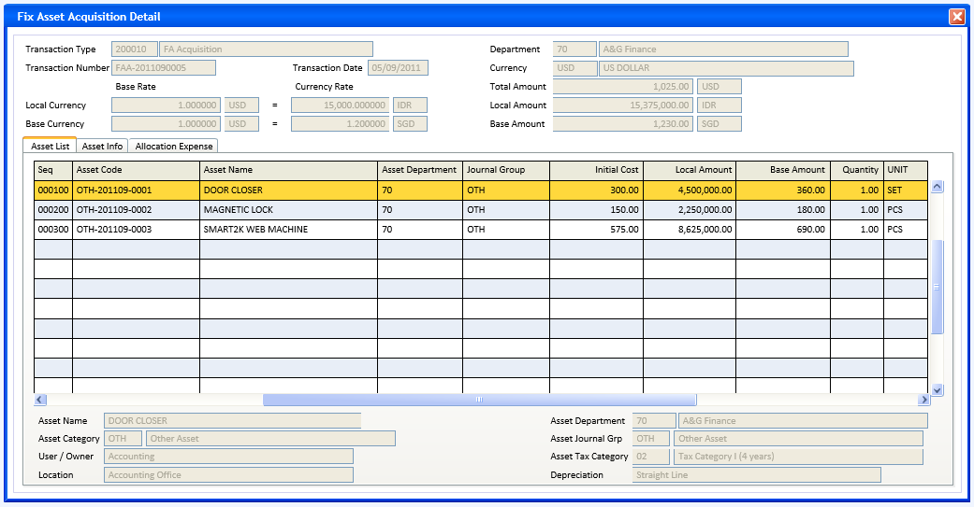
Form 2 Page 2 : FA Acquisition Detail – Asset Info – New asset --CR14 --CR21
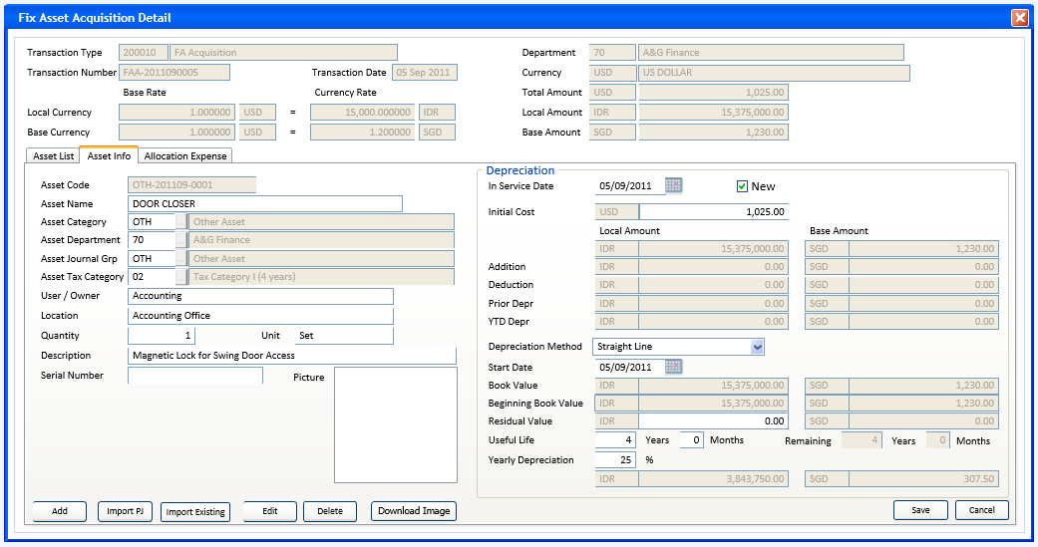

Form 2 Page 2 : FA Acquisition Detail – Asset Info – Existing Asset (not New) --CR14 --CR21
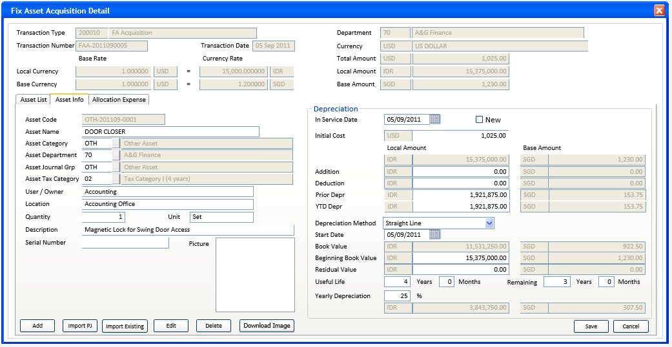

Form 2 Page 3 : FA Acquisition Detail – Allocation Expense
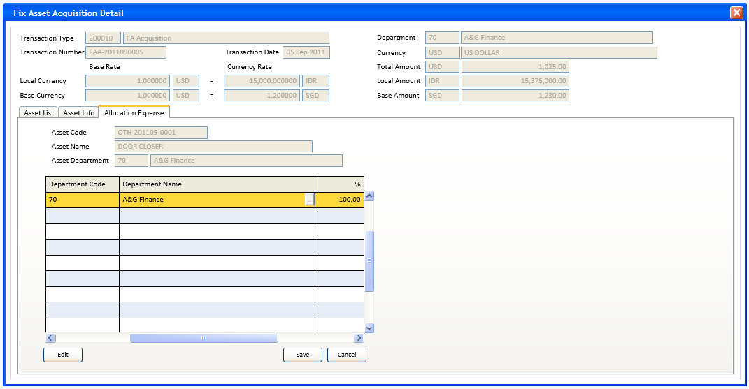

INITIAL PROCESS
Form 2 – FA Acquisition Detail
- Parameter from calling program: @PCMODE, @PCDEPT_CODE, @PCREFERENCE_NO
- Preparation for combobox Depreciation Method
SELECT CODE, DESCRIPTION
From RFT_GET_GSB_CODE_INFO(‘RHAPSODY’,{login_company_id},’_FA_DEPR_METHOD’,’’,{login language id})
Set Default Value to first row
- Display header fields and Asset List page fields
- If no row or only 1 row found in Asset List grid, then activate page Asset Info --CR20

- Go into Normal mode

BUTTON DEFINITION
Form 2 - FA Acquisition Detail – header | Test
Form 2 - FA Acquisition Detail – Asset List page
Form 2 - FA Acquisition Detail – Asset Info page
- Lookup Asset Category
- Run Prog GSL03000, with parameter {login_company_id}, ’51’, ’C’, ’’, {login_user_lang_id}
- Return value to Asset Category code and description
- Enabled in Add mode or Edit mode
- Lookup Asset Department
- Run Prog GSL00500, with parameter {login_company_id}, {login_user_lang_id}, 1
- Return value to Asset Department code and description
- Enabled in Add mode or Edit mode
- Lookup Asset Journal Group
- Run Prog GSL02000, with parameter {login_company_id}, ’6’, {login_user_lang_id} --CR12
- Return value to Asset Journal Group code and description
- Enabled in Add mode or Edit mode
- Lookup Asset Tax Category
- Run Prog FAL00400, with parameter {login_company_id}, {login_user_lang_id}
- Return value to Asset Tax Category code and description
- Enabled in Add mode or Edit mode
- Lookup Currency
- Run Prog HSL51200 with no parameter
- Return value to Currency code
- Enabled on Add mode or edit mode

- Add
- Enabled on Normal mode when @PCMODE = ’T’ and CSTATUS=’00’ and CFR_MODULE = ’FA’ --CR10
- Enable-disable input fields in the page (see Display Process)
- Enable-disable buttons in the page(see Button Definition)
- Set @CFR_SEQUENCE_NO = ’’
- Enter to Add mode
- Edit
- Enabled on Normal mode when @PCMODE = ’T’ and CSTATUS=’00’
- Enable-disable input fields in the page (see Display Process)
- Enable-disable button in the page (see Button Definition)
- Enter to Edit mode

- Delete
- Enabled on Normal mode when @PCMODE = ’T’ and CSTATUS=’00’
- Confirmation : ’You can not undo delete then. Are you sure to delete this asset ?’ (Yes/No)
- If ’Yes’ then do RSP_FAT00100_DELETE_ASSET with parameters : {login_company_id}, {Department code}, {Transaction Type code}, {Transaction Number}, {CTRANS_SEQNO}
- Back to form and refresh

- Save
- Enabled on Add or Edit mode
- Do VALIDATE ASSET, if not valid then back to form
- Do SAVE ASSET
- Back to Normal mode

- Cancel
- Enabled on Add or Edit mode
- Cancel data input and restore field’s value
- Back to normal mode

- Import PJ
- Enabled on Normal mode when @PCMODE = ’T’ and CSTATUS =’00’ and CFR_MODULE = ‘PJ’.
- Run form 3 with parameter : @PCFR_DEPT_CODE = CFR_DEPT_CODE,
@PCFR_TRANSACTION_CODE = CFR_TRANSACTION_CODE, @PCFR_REFERENCE_NO= CFR_REFERENCE_NO

- Import Existing --CR14
- Enabled on Normal mode when @PCMODE = ’T’ and CSTATUS =’00’ and CFR_MODULE = ‘FA’.
- Run form 4 with parameter : {Department code}, {Transaction Type code}, {Transaction Number}, @LASSET_INCREMENT_FLAG
- Refresh header Total Amount, Local Amount, Base Amount, and Asset List page’s grid
- Download Image
- Run function to get picture file
- Return value to Picture field
- Enabled in Add mode or Edit mode

Form 2 - FA Acquisition Detail – Allocation Expense
- Lookup Department (in grid)
- Run Prog GSL00500, with parameter {login_company_id}, {login_user_lang_id}, 1
- Return value to Department code and name
- Enabled in Edit mode, except for grid row with {Department code}={Asset Department code} is always disabled

- Edit
- Enabled on Normal mode when @PCMODE = ’T’ and CSTATUS=’00’
- Enable grid in the page except for grid row with {Department code}={Asset Department code} is always disabled
- Enable Lookup Department (in grid), Save button, and Cancel button
- Enter to Edit mode : user can add/edit/delete directly from the grid

- Save
- Enabled on Edit mode
- Do SAVE ALLOCATION EXPENSE flush grid data to database table
- Back to Normal mode

- Cancel
- Enabled on Edit mode
- Cancel data input in grid and restore to the initial data
- Back to normal mode

OUTPUT
Test
- None

DISPLAY PROCESS
Form 1 - FA Acquisition Detail – header
- Query to fill header fields
SELECT CDEPT_CODE, CTRANSACTION_CODE, CREFERENCE_NO, CTRANSACTION_DATE, CSTATUS, CCURRENCY_CODE,
NLBASE_RATE_AMOUNT, NLCURRENCY_RATE_AMOUNT, NBBASE_RATE_AMOUNT, NBCURRENCY_RATE_AMOUNT,
NTRANSACTION_AMOUNT, NLTRANSACTION_AMOUNT, NBTRANSACTION_AMOUNT,
CDOCUMENT_DATE, CSUPPLIER_ID, CSUPPLIER_NAME,
CFR_MODULE, CFR_DEPT_CODE, CFR_TRANSACTION_CODE, CFR_REFERENCE_NO, a.DUPDATE_DATE --CR18
CDEPT_NAME = ISNULL(b.DESCRIPTION,’’),
CCURRENCY_NAME = ISNULL(CCURRENCY_NAME,’’),
CTRANSACTION_NAME = ISNULL(CTRANSACTION_NAME,’’),
NLRATE = ROUND(NLCURRENCY_RATE_AMOUNT / NLBASE_RATE_AMOUNT, 6), --CR6
NBRATE = ROUND(NBCURRENCY_RATE_AMOUNT / NBBASE_RATE_AMOUNT, 6),
NBXRATE = ROUND((NBCURRENCY_RATE_AMOUNT * NLBASE_RATE_AMOUNT)/(NLCURRENCY_RATE_AMOUNT *
NBBASE_RATE_AMOUNT), 6),
FROM FAT_TRANS_HD a (nolock)
LEFT JOIN RFT_GET_GSB_CODE_INFO(‘RHAPSODY’, {login_company_id}, ’_DEPARTMENT’,’’,
{login language id}) b ON b.CODE = a.CDEPT_CODE
LEFT JOIN SAB_CURRENCY c (nolock) ON c.CCURRENCY_CODE = a.CCURRENCY_CODE
LEFT JOIN GSM_TRANSACTION_CODE d (nolock) ON d.CCOMPANY_ID=a.CCOMPANY_ID and
d.CTRANSACTION_CODE=a.CTRANSACTION_CODE
WHERE a.CCOMPANY_ID={login_company_id} AND a.DEPT_CODE={@PCDEPT_CODE} AND a.CTRANSACTION_CODE =
{@CFILTER_TRANS_CODE} AND a.CREFERENCE_NO=@PCREFERENCE_NO
    - FIELD DEFINITION
All fields are read only
  - Transaction Type code
    - Field : CTRANSACTION_CODE varchar(6)

  - Transaction Type description
    - Field : CTRANSACTION_NAME nvarchar(60)

  - Transaction Number
    - Field : CREFERENCE_NO varchar(30)

  - Transaction Date
    - Field : CTRANSACTION_DATE char(8) display with date format
  - Department code
    - Field : CDEPT_CODE varchar(8)

  - Department name
    - Field : CDEPT_NAME nvarchar(60)

  - Currency code
    - Field : CCURRENCY_CODE varchar(3)

  - Currency name
    - Field : CCURRENCY_NAME nvarchar(60)

  - Local Currency – Base Rate – currency code
    - Field : CCURRENCY_CODE varchar(3)

  - Local Currency – Base Rate – amount
    - Field : NLBASE_RATE_AMOUNT numeric 6 decimal

  - Local Currency – Currency Rate – currency code
    - Field : @CLOCAL_CURRENCY_CODE varchar(3)

  - Local Currency – Currency Rate – amount
    - Field : NLCURRENCY_RATE_AMOUNT numeric 6 decimal

  - Base Currency – Base Rate – currency code
    - Field : CCURRENCY_CODE varchar(3)

  - Base Currency – Base Rate – amount
    - Field : NBBASE_RATE_AMOUNT numeric 6 decimal

  - Base Currency – Currency Rate – currency code
    - Field : @CBASE_CURRENCY_CODE varchar(3)

  - Base Currency – Currency Rate – amount
    - Field : NBCURRENCY_RATE_AMOUNT numeric 6 decimal

  - Total Amount – amount
    - Field : NTRANSACTION_AMOUNT numeric 2 decimal,

  - Total Amount – currency code
    - Field : CCURRENCY_CODE varchar(3)

  - Local Amount – amount
    - Field : NLTRANSACTION_AMOUNT numeric 2 decimal,

  - Local Amount – currency code
    - Field : @CLOCAL_CURRENCY_CODE varchar(3)

  - Base Amount – amount
    - Field : NBTRANSACTION_AMOUNT numeric 2 decimal,

  - Base Amount – currency code
    - Field : @CBASE_CURRENCY_CODE varchar(3)

Form 1 - FA Acquisition Detail – Asset List page
- Query to fill grid fields
SELECT a.CASSET_CODE, CTRANS_SEQNO, CASSET_TRANS_SEQNO, NTRANSACTION_AMOUNT1, NLTRANSACTION_AMOUNT1,
NBTRANSACTION_AMOUNT1, ITRANSACTION_QTY1, CUNIT, CASSET_DEPT_CODE, CASSET_LOCATION, CJRNGRP_CODE,
CTAX_CATEGORY_CODE, CCATEGORY_CODE, CDEPR_METHOD, CASSET_NAME, CASSET_OWNER
FROM FAT_TRANS_ASSET a (nolock)
INNER JOIN FAM_ASSET b (nolock) ON b.CCOMPANY_ID=a.CCOMPANY_ID and b.CASSET_CODE=a.CASSET_CODE
WHERE a.CCOMPANY_ID={login_company_id} AND a.DEPT_CODE={@PCDEPT_CODE} AND a.CTRANSACTION_CODE =
{@CFILTER_TRANS_CODE} AND a.CREFERENCE_NO={@PCREFERENCE_NO} AND a.LDELETE_FLAG=0
(({header.CSTATUS}<’09’ and a.LDELETE_FLAG=0) or ({header.CSTATUS}>’08’ and
a.DUPDATE_DATE={header.DUPDATE_DATE})) --CR18
    - GRID COLUMNS DEFINITION
All columns are read only
  - Seq
    - Field : CTRANS_SEQNO varchar(6)

  - Asset Code
    - Field : CASSET_CODE varchar(20)

  - Asset Name
    - Field : CASSET_NAME nvarchar(60)

  - Asset Department
    - Field : CASSET_DEPT_CODE varchar(8)

  - Journal Group
    - Field : CJRNGRP_CODE varchar(5)

  - Initial Cost
    - Field : NTRANSACTION_AMOUNT1 numeric 2 decimal

  - Local Amount
    - Field : NLTRANSACTION_AMOUNT1 numeric 2 decimal

  - Base Amount
    - Field : NBTRANSACTION_AMOUNT1 numeric 2 decimal

  - Quantity
    - Field : ITRANSACTION_QTY1 integer

  - Unit
    - Field : CUNIT varchar(6)

    - GRID’s ADDITIONAL INFO DEFINITION
As detail of current grid row, all fields are read only.
  - Asset Name
    - Field : CASSET_NAME nvarchar(60)

  - Asset Category code
    - Field : CCATEGORY_CODE varchar(6)

  - Asset Category description
    - Field : @CCATEGORY_DESC nvarchar(60)
Select @CCATEGORY_DESC=ISNULL(b.CDESCRIPTION,a.CCATEGORY_DESC)
From GSM_CATEGORY a (nolock)
LEFT JOIN GSM_TRANSLATE b (nolock) ON b.CTABLE_NAME=’GSM_CATEGORY’ AND CFOREIGN_LANGUAGE=
(login_user_Lang_id) AND b.CKEY_ID = CCOMPANY_ID + CCATEGORY_ITEM + CCATEGORY_TYPE +
CCATEGORY_CODE
where CCOMPANY_ID={login_company_id} and CCATEGORY_ITEM=’51’ and CCATEGORY_TYPE=’C’ and
CCATEGORY_CODE={CCATEGORY_CODE}

  - User/Owner
    - Field : CASSET_OWNER nvarchar(30)

  - Location
    - Field : CASSET_LOCATION nvarchar(60)

  - Asset Department code
    - Field : CASSET_DEPT_CODE varchar(8)

  - Asset Department description
    - Field : @CDEPT_NAME nvarchar(60)
Select @CDEPT_NAME = y.DESCRIPTION
From RFT_GET_GSB_CODE_INFO(‘RHAPSODY’, {login_company_id},’_DEPARTMENT’,’’,{login language id}) y
WHERE y.CODE = {CASSET_DEPT_CODE}
  - Asset Journal Group code
    - Field : CJRNGRP_CODE varchar(5)

  - Asset Journal Group description
    - Field : @CJRNGRP_NAME nvarchar(60)
Select @CJRNGRP_NAME = ISNULL(b.CDESCRIPTION, a.CJRNGRP_NAME)
From GSM_JRNGRP_HD a (nolock)
LEFT JOIN GSM_TRANSLATE b (nolock) ON b.CTABLE_NAME=’GSM_JRNGRP_HD’ AND b.CFOREIGN_LANGUAGE=
{login_user_Lang_id} AND b.CKEY_ID=a.CCOMPANY_ID+a.CJRNGRP_TYPE+a.CJRNGRP_CODE
Where a.CCOMPANY_ID={login_company_id} and a.CJRNGRP_TYPE=’6’ and
a.CJRNGRP_CODE={CJRNGRP_CODE}

  - Asset Tax Category code
    - Field : CTAX_CATEGORY_CODE varchar(8)

  - Asset Tax Category description
    - Field : @CTAX_CATEGORY_DESC nvarchar(60)
Select @CTAX_CATEGORY_DESC=ISNULL(b.CDESCRIPTION, a.CTAX_CATEGORY_DESC)
From FAM_TAX_CATEGORY a (nolock)
LEFT JOIN GSM_TRANSLATE b (nolock) ON b.CTABLE_NAME=’FAM_TAX_CATEGORY’ AND
b.CFOREIGN_LANGUAGE={login_user_Lang_id} AND b.CKEY_ID=a.CCOMPANY_ID+a.CTAX_CATEGORY_CODE
Where a.CCOMPANY_ID={login_company_id} and a.CTAX_CATEGORY_CODE = {CTAX_CATEGORY_CODE}
  - Depreciation
    - Field : @CDEPR_METHOD_DESC nvarchar(60)
Select @CDEPR_METHOD_DESC = y.DESCRIPTION
From RFT_GET_GSB_CODE_INFO(‘RHAPSODY’, {login_company_id},’_FA_DEPR_METHOD’,’’,
{login language id}) y
WHERE y.CODE = {CDEPR_METHOD}

Form 1 - FA Acquisition Detail – Asset Info page
- This page contains detail data of current row of grid in Asset List page
User can add, edit, and delete asset data on this page
- Query to fill Asset Info page fields --CR5
SELECT a.CASSET_CODE, a.CTRANS_SEQNO, a.CASSET_TRANS_SEQNO, a.NTRANSACTION_AMOUNT1, a.NLTRANSACTION_AMOUNT1,
a.NLTRANSACTION_AMOUNT2, a.NLTRANSACTION_AMOUNT3, a.NLTRANSACTION_AMOUNT4, a.NLTRANSACTION_AMOUNT5,
a.NBTRANSACTION_AMOUNT1, a.NBTRANSACTION_AMOUNT2, a.NBTRANSACTION_AMOUNT3, a.NBTRANSACTION_AMOUNT4,
a.NBTRANSACTION_AMOUNT5, a.ITRANSACTION_QTY1, a.CUNIT, a.CTRANSACTION_DESCR, a.CASSET_DEPT_CODE,
a.CASSET_LOCATION, a.CJRNGRP_CODE, a.CTAX_CATEGORY_CODE, a.CCATEGORY_CODE, a.CDEPR_METHOD,
a.CSTART_DATE, a.NLBOOK_VALUE, a.NBBOOK_VALUE, a.IUSEFUL_LIVE, a.NLYEAR_DEPR_AMT, a.NBYEAR_DEPR_AMT,
a.NLRESIDUAL_VALUE, a.NBRESIDUAL_VALUE, a.NYEAR_DEPR_PCT, b.CASSET_NAME, b.CSERIAL_NUMBER,
b.CASSET_OWNER, b.OASSET_IMAGE, b.CINSERVICE_DATE, b.LNEW_FLAG,
IUSEFUL_LIVE_YR = FLOOR(a.IUSEFUL_LIVE / 12), IUSEFUL_LIVE_MO = MOD(a.IUSEFUL_LIVE / 12),
a.NOLBOOK_VALUE, a.NOBBOOK_VALUE, a.IOUSEFUL_LIVE, --CR21
IOUSEFUL_LIVE_YR = FLOOR(a.IOUSEFUL_LIVE / 12), IOUSEFUL_LIVE_MO = MOD(a.IOUSEFUL_LIVE / 12), --CR21
CASSET_DEPT_NAME = ISNULL(q.DESCRIPTION,’’),
CJRNGRP_DESC = ISNULL(r1.CDESCRIPTION, r.CJRNGRP_NAME),
CCATEGORY_DESC = ISNULL(s1.CDESCRIPTION, s.CCATEGORY_DESC),
CTAX_CATEGORY_DESC = ISNULL(u1.CDESCRIPTION, u.CTAX_CATEGORY_DESC)
FROM FAT_TRANS_ASSET a (nolock)
INNER JOIN FAM_ASSET b (nolock) ON b.CCOMPANY_ID=a.CCOMPANY_ID and b.CASSET_CODE=a.CASSET_CODE
LEFT JOIN RFT_GET_GSB_CODE_INFO(‘RHAPSODY’, {login_company_id}, ’_DEPARTMENT’,’’,
{login language id}) q ON q.CODE = a.CASSET_DEPT_CODE
LEFT JOIN GSM_JRNGRP_HD r (nolock) ON r.CCOMPANY_ID=a.CCOMPANY_ID and r.CJRNGRP_TYPE=’6’ and
r.CJRNGRP_CODE=a.CJRNGRP_CODE
LEFT JOIN GSM_TRANSLATE r1 (nolock) ON r1.CTABLE_NAME=’GSM_JRNGRP_HD’ AND r1.CFOREIGN_LANGUAGE=
{login_user_Lang_id} AND r1.CKEY_ID=r.CCOMPANY_ID+r.CJRNGRP_TYPE+r.CJRNGRP_CODE
LEFT JOIN GSM_CATEGORY s (nolock) ON s.CCOMPANY_ID=a.CCOMPANY_ID and s.CCATEGORY_ITEM=’51’ and
s.CCATEGORY_TYPE=’C’ and s.CCATEGORY_CODE=a.CCATEGORY_CODE
LEFT JOIN GSM_TRANSLATE s1 (nolock) ON s1.CTABLE_NAME=’GSM_CATEGORY’ AND s1.CFOREIGN_LANGUAGE=
{login language id} AND s1.CKEY_ID = s.CCOMPANY_ID+s.CCATEGORY_ITEM + s.CCATEGORY_TYPE +
s.CCATEGORY_CODE
LEFT JOIN FAM_TAX_CATEGORY u (nolock) on u.CCOMPANY_ID=a.CCOMPANY_ID and u.CTAX_CATEGORY_CODE =
a.COTAX_CATEGORY_CODE
LEFT JOIN GSM_TRANSLATE u1 (nolock) ON u1.CTABLE_NAME=’FAM_TAX_CATEGORY’ AND
u1.CFOREIGN_LANGUAGE={login_user_Lang_id} AND u1.CKEY_ID=u.CCOMPANY_ID+u.CTAX_CATEGORY_CODE
WHERE a.CCOMPANY_ID={login_company_id} AND a.CDEPT_CODE={@PCDEPT_CODE} AND a.CTRANSACTION_CODE =
{@CFILTER_TRANS_CODE} AND a.CREFERENCE_NO={@PCREFERENCE_NO} AND
CASSET_CODE={Asset List grid.CASSET_CODE}
    - FIELDS DEFINITION
  - Asset Code
    - Field : CASSET_CODE varchar(20)
    - Default value = ’’
    - Enabled in add mode when @LASSET_INCREMENT_FLAG = 0, user should fill out this field
    - When in add mode and @LASSET_INCREMENT_FLAG = 1, this field is remained empty and disabled, and its value will be generated in SAVE ASSET process

  - Asset Name
    - Field : CASSET_NAME nvarchar(60)
    - Enabled in add or edit mode

  - Asset Category code
    - Field : CCATEGORY_CODE varchar(6)
    - Enabled in add or edit mode
    - Use lookup validation

  - Asset Category description --CR5
    - Field : CCATEGORY_DESC or {lookup.description} nvarchar(60)
    - Always disabled
  - Asset Department code
    - Field : CASSET_DEPT_CODE varchar(8)
    - Enabled in add mode or (edit mode and (@LASSET_INCREMENT_FLAG = 0 or @LDEPT_MODE = 0))
    - Default value = @CDEFAULT_ASSET_DEPT_CODE --CR9
    - Use lookup validation
    - If {lookup.LEVERYONE_FLAG} = 0 then Validate found in :
Select * From GSX_DEPARTMENT_USER (nolock)
Where CCOMPANY_ID = {login_company_id} and CDEPT_CODE={Department code}
AND CUSER_ID = {login_user_id}
Message : You have no rights to access this Department
  - Asset Department description --CR5
    - Field : CASSET_DEPT_NAME or {lookup.description} nvarchar(60)
    - Always disabled
  - Asset Journal Group code
    - Field : CJRNGRP_CODE varchar(5)
    - Enabled in add mode or (edit mode and (@LASSET_INCREMENT_FLAG = 0 or @LJRNGRP_MODE = 0))
    - Use lookup validation

  - Asset Journal Group description --CR5
    - Field : CJRNGRP_DESC or {lookup.description} nvarchar(60)
    - Always disabled
  - Asset Tax Category code
    - Field : CTAX_CATEGORY_CODE varchar(8)
    - Enabled in add or edit mode
    - Use lookup validation

  - Asset Tax Category description --CR5
    - Field : CTAX_CATEGORY_DESC or {lookup.description} nvarchar(60)
    - Always disabled
  - User/Owner
    - Field : CASSET_OWNER nvarchar(30)
    - Enabled in add or edit mode

  - Location
    - Field : CASSET_LOCATION nvarchar(60)
    - Enabled in add or edit mode

  - Quantity
    - Field : ITRANSACTION_QTY1 integer
    - Enabled in add or edit mode
    - Default value = 1

  - Unit
    - Field : CUNIT varchar(6)
    - Enabled in add or edit mode

  - Description
    - Field : CTRANSACTION_DESCR nvarchar(300)
    - Enabled in add or edit mode

  - Serial Number
    - Field : CSERIAL_NUMBER varchar(30)
    - Enabled in add or edit mode
  - Picture
    - Field : OASSET_IMAGE object
    - Enabled in add or edit mode
    - Get picture object from function button
  - In Service Date
    - Field : CINSERVICE_DATE varchar(8) use date format
    - Enabled in add or edit mode
    - Default value = {Transaction Date}

  - New
    - Field : LNEW_FLAG bit use checkbox (0/1)
    - Enabled in add or edit mode
    - Default value = 1 (checked)
    - Replace value and enable/disable Local Amount of : Addition, Deduction, Prior Depr, YTD Depr,
Beginning Book Value, Remaining Useful Life years/months --CR21

  - Initial Cost currency
    - Field : header.CCURRENCY_CODE varchar(3)
    - Always disabled

  - Initial Cost amount
    - Field : NTRANSACTION_AMOUNT1 numeric 2 decimal
    - Enabled in add or edit mode
    - Recalculate Local Amount, Base Amount of : Initial Cost, Book Value, Beginning Book Value, Yearly Depreciation --CR21

  - Local Amount currencys’ (Addition, Deduction, Prior Depr, YTD Depr, Book Value, Beginning Book Value, Residual Value, Yearly Depreciation) --CR21
    - Field : @CLOCAL_CURRENCY_CODE varchar(3)
    - Always disabled
  - Base Amount currencys’ (Addition, Deduction, Prior Depr, YTD Depr, Book Value, Beginning Book Value, Residual Value, Yearly Depreciation) --CR21
    - Field : @CBASE_CURRENCY_CODE varchar(3)
    - Always disabled
  - Initial Cost Local Amount
    - Field : NLTRANSACTION_AMOUNT1 numeric 2 decimal
    - Recalculated value : ROUND({header.NLRATE} * {Initial Cost amount},2)
    - Always disabled
  - Initial Cost Base Amount
    - Field : NBTRANSACTION_AMOUNT1 numeric 2 decimal
    - Recalculated value : ROUND({header.NBRATE} * {Initial Cost amount},2)
    - Always disabled
  - Addition Local Amount
    - Field : NLTRANSACTION_AMOUNT2 numeric 2 decimal
    - Replaced value : If {New}=1 then set value = 0.00
    - Enabled in Add or Edit mode when {New}=0
    - Recalculate : Addition Base Amount

  - Addition Base Amount
    - Field : NBTRANSACTION_AMOUNT2 numeric 2 decimal
    - Always disabled
    - Recalculated value : ROUND({header.NBXRATE} * {Addition Local amount},2)
  - Deduction Local Amount
    - Field : NLTRANSACTION_AMOUNT3 numeric 2 decimal
    - Replaced value : If {New}=1 then set value = 0.00
    - Enabled in Add or Edit mode when {New}=0
    - Recalculate : Deduction Base Amount
  - Deduction Base Amount
    - Field : NBTRANSACTION_AMOUNT3 numeric 2 decimal
    - Always disabled
    - Recalculated value : ROUND({header.NBXRATE} * {Deduction Local amount},2)

  - Prior Depr Local Amount
    - Field : NLTRANSACTION_AMOUNT4 numeric 2 decimal
    - Replaced value : If {New}=1 then set value = 0.00
    - Enabled in Add or Edit mode when {New}=0
    - Recalculate : Prior Depr Base Amount

  - Prior Depr Base Amount
    - Field : NBTRANSACTION_AMOUNT4 numeric 2 decimal
    - Always disabled
    - Recalculated value : ROUND({header.NBXRATE} * {Prior Depr Local Amount},2)

  - YTD Depr Local Amount
    - Field : NLTRANSACTION_AMOUNT5 numeric 2 decimal
    - Replaced value : If {New}=1 then set value = 0.00
    - Enabled in Add or Edit mode when {New}=0
    - Recalculate : YTD Depr Base Amount

  - YTD Depr Base Amount
    - Field : NBTRANSACTION_AMOUNT5 numeric 2 decimal
    - Always disabled
    - Recalculated value : ROUND({header.NBXRATE} * {YTD Depr Local Amount},2)

  - Depreciation Method
    - Field : CDEPR_METHOD char(1), use combobox, display description only, get code
    - ‘0’ – Non Depreciated
    - ‘1’ = Straight Line
    - ‘2’ = Declining --CR17
    - ‘3’ = Double Declining
    - ‘9’ = Manual
    - Enabled in Add or Edit mode
    - Set enable/disable : Start Date, Residual Value, Useful Life years/months, Yearly Depreciation %,
Remaining Useful Life years/months --CR21
    - Refresh value : Start Date, Residual Value, Useful Life years/months, Yearly Depreciation %, Yearly Depreciation amounts, Remaining Useful Life years/months --CR21

  - Start Date
    - Field : CSTART_DATE varchar(8), display with date format
    - Enabled in Add or Edit mode when {Depreciation Method}<>’0’
    - Replaced value : If {Depreciation Method} changed to ’0’ then set value = ’’ else set default value = if {In Service Date}>{Transaction Date} then {In Service Date} else {Transaction Date}
  - Book Value – Local Amount
    - Field : NLBOOK_VALUE numeric 2 decimal
    - Recalculated value : Local Amount {Initial Cost} + {Addition} – {Deduction} – {Prior Depr} – {YTD Depr}
    - Always disabled
    - On value change refresh Beginning Book Value Local Amount and Beginning Book Value Base Amount --CR21
  - Book Value – Base Amount
    - Field : NBBOOK_VALUE numeric 2 decimal
    - Recalculated value : Base Amount {Initial Cost} + {Addition} – {Deduction} – {Prior Depr} – {YTD Depr}
    - Always disabled

  - Beginning Book Value – Local Amount --CR21
    - Field : NOLBOOK_VALUE numeric 2 decimal
    - Default value = 0.00
    - Recalculated value : if [New]=1 then {Book Value Local Amount}
else no value changed
    - Enabled in Add or Edit mode when [New]=0
    - Recalculate Beginning Book Value Base Amount
  - Beginning Book Value – Base Amount --CR21
    - Field : NOBBOOK_VALUE numeric 2 decimal
    - Recalculated value : if [New]=1 then {Book Value Base Amount}
else ROUND({header.NBXRATE} * {Beginning Book Value Local amount},2)
    - Always disabled
  - Residual Value – Local Amount
    - Field : NLRESIDUAL_VALUE numeric 2 decimal
    - Enabled in Add or Edit mode when {Depreciation Method}<>’0’
    - Default value = 0.00
    - Validate < Beginning Book Value Local Amount --CR21
Message : Please enter a valid Residual Value less than Beginning Book Value --CR21
    - Refresh {Residual Value Base Amount}, {Yearly Depreciation Local Amount} --CR2
    - Refreshed value : when {Depreciation Method} = ’0’ then set value to 0.00 --CR2
  - Residual Value – Base Amount
    - Field : NBRESIDUAL_VALUE numeric 2 decimal
    - Always disabled
    - Recalculated value : ROUND({header.NBXRATE} * {Residual Value Local Amount},2)

  - Useful Life – years
    - Field : IUSEFUL_LIVE_YR IOUSEFUL_LIVE_YR smallint --CR21
    - Enabled in Add or Edit mode when {Depreciation Method}<>’0’
    - If {Depreciation Method}=’3’ then validate value >= 2 --CR17
Message : Please enter a valid number with minimum 2 years for Double Declining method
    - If value changed then Recalculate : Yearly Depreciation %, Yearly Depreciation Local Amount, Yearly Depreciation Base Amount, Remaining Useful Life years --CR21
    - Recalculated value :
When {Depreciation Method} = ’0’ then set value to 0 else FLOOR(100 iif({Depreciation Method}=’3’, 200, 100) /{Yearly Depreciation%}) --CR2 --CR17
When {Depreciation Method} changed from ’0’ then set value to 10 --CR7
  - Useful Life – months
    - Field : IUSEFUL_LIVE_MO IOUSEFUL_LIVE_MO smallint --CR21
    - Enabled in Add or Edit mode when {Depreciation Method}<>’0’
    - Validate value between 0 and 11
Message : Please enter a valid number of month between 0 and 11
    - If value changed then Recalculate : Yearly Depreciation %, Yearly Depreciation Local Amount, Yearly Depreciation Base Amount, Remaining Useful Life months --CR21
    - Recalculated value : When {Depreciation Method} = ’0’ then set value to 0 else (100 iif({Depreciation Method}=’3’, 200, 100) /{Yearly Depreciation%}*12) MODULUS 12 rounded up to integer –CR2 --CR8 --CR17
  - Remaining Useful Life – years --CR21
    - Field : IUSEFUL_LIVE_YR smallint
    - Enabled in Add or Edit mode when {New}=0 and {Depreciation Method}<>’0’
    - Recalculated value : If {Depreciation Method} = ’0’ then 0
else If {New}=1 then {Useful Life years)
else no value update
    - If value changed and {New}=1 and {Depreciation Method} in(’2’,’3’) then Recalculate : Yearly Depreciation Local Amount, Yearly Depreciation Base Amount --CR22
  - Remaining Useful Life – months --CR21
    - Field : IUSEFUL_LIVE_MO smallint
    - Enabled in Add or Edit mode when {New}=0 and {Depreciation Method}<>’0’
    - Validate value between 0 and 11
Message : Please enter a valid number of month between 0 and 11
    - Recalculated value : If {Depreciation Method} = ’0’ then 0
else If {New}=1 then {Useful Life months)
else no update
    - If value changed and {New}=1 and {Depreciation Method} in(’2’,’3’) then Recalculate : Yearly Depreciation Local Amount, Yearly Depreciation Base Amount --CR22
  - Yearly Depreciation - %
    - Field : NYEAR_DEPR_PCT numeric 6,2 decimal
    - Enabled in Add or Edit mode when {Depreciation Method}= ’1’ or ’2’ or ’3’ --CR17
    - Validate value between 0.01 and 100.00 --CR17
If {Depreciation Method}<>’3’ then validate value between 0.01 and 1200.00
If {Depreciation Method}=’3’ then validate value between 0.01 and 100.00
Message : Please enter a valid percentage value
    - Validate (100/{Yearly Depreciation%}*12) is an integer number (no decimal value)
Message : Please enter a percentage value resulting a round number of Useful Life months --CR8
    - If value changed then recalculate : Useful Life years, Useful Life months, Yearly Depreciation Local Amount, Yearly Depreciation Base Amount.
    - Recalculated value : if {Depreciation Method}<>’1’ in(’0’,’9’) then 0.00 else 100 iif({Depreciation Method}=’3’, 200, 100) / ((({Useful Life years} * 12) + {Useful Life months}) / 12) rounded 2 decimal --CR7 --CR17

  - Yearly Depreciation – Local Amount
    - Field : NLYEAR_DEPR_AMT numeric 5, 2 decimal
    - Recalculated value : if {Depreciation Method} in(’0’,’9’) then 0.00 else ({Beginning Book Value Local Amount} – iif({Depreciation Method}=’1’,{Residual Value Local Amount}, 0)) / ((({Useful Life years} * 12) + {Useful Life months}) / 12) * iif({Depreciation Method}=’3’,2,1) rounded 2 decimal
--CR7 --CR17 --CR21
    - If {New}=1 and {Depreciation Method} in(’2’,’3’) then call function GetDecliningDeprAmount to get Recalculated value, with parameter : {Depreciation Method}, {Useful Life years}, {Useful Life months}, {Remaining Useful Life years}, {Remaining Useful Life months}, {Beginning Book Value Local Amount} --CR22

    - Always disabled

  - Function : RSP_FA_GET_DECL_YEARLY_DEPR_AMT --CR22
Parameters :
@DeprMet char(1),
@BegULYr smallint,
@BegULMo smallint,
@RemULYr smallint,
@RemULMo smallint,
@BegBookVal numeric(18,2)
declare
@YearSeq smallint,
@BookVal numeric(18,2),
@DeprAmt numeric(18,2),
@DeprPct numeric(6,2),
@x smallint
set @DeprPct = round(iif(@DeprMet='3', 200, 100) / (((@BegULYr * 12) + @BegULMo) / 12), 2)
set @YearSeq = ceiling((((@BegULYr * 12) + @BegULMo) - ((@RemULYr * 12) + @RemULMo) + 1.00) / 12)
set @x = 1
set @BookVal = @BegBookVal
while @x <= @YearSeq begin
set @DeprAmt = round(@BookVal * @DeprPct / 100, 2)
set @BookVal = @BookVal - @DeprAmt
set @x = @x + 1
end
RETURN @DeprAmt

  - Yearly Depreciation – Base Amount
    - Field : NBYEAR_DEPR_AMT numeric 5, 2 decimal
    - Recalculated value : if {Depreciation Method}<>’1’ in(’0’,’9’) then 0.00 else ({Beginning Book Value Base Amount} – iif({Depreciation Method}=’1’,{Residual Value Base Amount}, 0)) / ((({Useful Life years} * 12) + {Useful Life months}) / 12) * iif({Depreciation Method}=’3’,2,1) rounded 2 decimal --CR7 --CR17 --CR21
    - If {New}=1 and {Depreciation Method} in(’2’,’3’) then call function GetDecliningDeprAmount to get Recalculated value, with parameter : {Depreciation Method}, {Useful Life years}, {Useful Life months}, {Remaining Useful Life years}, {Remaining Useful Life months}, {Beginning Book Value Base Amount} --CR22

    - Always disabled

Form 1 - FA Acquisition Detail – Allocation Expense page
- This page contains child data of Asset Info page

- HEADER FIELDS DEFINITION
All fields are read only

  - Asset Code
    - Field : CASSET_CODE varchar(20)

  - Asset Name
    - Field : CASSET_NAME nvarchar(60)

  - Asset Department code
    - Field : CASSET_DEPT_CODE varchar(8)

  - Asset Department description
    - Field : @CDEPT_NAME nvarchar(60)
Select @CDEPT_NAME = y.DESCRIPTION
From RFT_GET_GSB_CODE_INFO(‘RHAPSODY’, {login_company_id},’_DEPARTMENT’,’’,{login language id}) y
WHERE y.CODE = {CASSET_DEPT_CODE}
- Query to fill grid

SELECT CEXPENSE_DEPT_CODE, NEXPENSE_PCT, CEXPENSE_DEPT_NAME = isnull(y.DESCRIPTION,’’)
FROM FAT_TRANS_EXP_ALLOC a (nolock)
LEFT JOIN RFT_GET_GSB_CODE_INFO(‘RHAPSODY’, {login_company_id},’_DEPARTMENT’,’’,{login language id}) y
on y.CODE = a.CEXPENSE_DEPT_CODE
WHERE a.CCOMPANY_ID={login_company_id} AND a.CDEPT_CODE={Department code} AND a.CTRANSACTION_CODE =
{Transaction Type code} AND a.CREFERENCE_NO={Transaction Number} and a.CASSET_CODE = {CASSET_CODE}
AND a.CASSET_TRANS_SEQNO={CASSET_TRANS_SEQNO}
- Default display order by CEXPENSE_DEPT_CODE, go top record

    - GRID COLUMN DEFINITION
When in Edit Mode, grid is enabled for add, edit and delete data rows, except for row with {Department Code} = {Asset Department Code} is always disabled (read only) for user.
Grid data source is a cursor, will be flushed to update table FAT_TRANS_EXP_ALLOC when SAVE button clicked

  - Department code
    - Field : CEXPENSE_DEPT_CODE varchar(8)
    - Enabled in edit mode when add row (disabled when edit row).
    - Default value = ’’
    - Use lookup validation
    - If {lookup.LEVERYONE_FLAG} = 0 then Validate found in :
Select * From GSX_DEPARTMENT_USER (nolock)
Where CCOMPANY_ID = {login_company_id} and CDEPT_CODE={Department code}
AND CUSER_ID = {login_user_id}
Message : You have no rights to access this Department
  - Department name
    - Field : {lookup description} nvarchar(60)
    - Always Disabled
  - %
    - Field : NEXPENSE_PCT numeric 2 decimal
    - Enabled in edit mode
    - Default value : 0.00
    - Validate > 0.00 and < 100.00
Message : Please enter a valid percentage amount

    - GRID’s ROW LEVEL VALIDATION
    - Validate {Department code} not empty
Message : Please enter a Department code
    - Validate {Department code} not duplicated to the one of other row
Message : Please enter a different Department code not duplicated to the one of other row
    - Validate (new{%} – old{%}) is less than {%} of row with {Department Code} = {Asset Department Code}
Message : Please enter a percentage amount not exceeds the one of Asset Department
    - GRID’s ROW LEVEL ADDITIONAL UPDATE
Update row where {Department Code} = {Asset Department Code} to get total of all row’s {%} always 100.00
    - When add row : set {%} = {%} – current row {%}
    - When edit row : set {%} = {%} – (current row new{%} – current row old{%})
    - When delete row : set {%} = {%} + current row {%}

VALIDATE ASSET
For Add Mode and Edit Mode | Test
  - Validation :
    - {Asset Name} <> ’’
Message : Asset Name should not be empty
    - {Asset Category} <> ’’
Message : Asset Category should not be empty
    - {Asset Department} <> ’’
Message : Asset Department should not be empty
    - {Asset Journal Group} <> ’’
Message : Asset Journal Group should not be empty
    - {Asset Tax Category} <> ’’
Message : Asset Tax Category should not be empty
    - {Asset Quantity} <> 0
Message : Please enter a valid Asset Quantity not equal to zero
    - {Asset Unit} <> ’’
Message : Asset Unit should not be empty
    - {In Service Date} <> ’’
Message : Please enter a valid In Service Date
    - {New}=0 or {In Service Date} >= {Transaction Date}
Message : Please enter In Service Date not before Transaction Date
    - {Depreciation Method} = ’0’ or {Start Date} <> ’’ --CR2
Message : Please enter a valid Start Date for depreciation
    - {Depreciation Method} = ’0’ or ({Start Date} >= {In Service Date} and {Start Date} >= {Transaction Date}) --CR2
Message : Please enter Start Date not before In Service Date and Transaction Date
    - {Initial Cost} <> 0.00
Message : Please enter a valid amount of Initial Cost
    - {Depreciation Method} = ’0’ or {Useful Life years} <> 0 or {Useful Life months} <> 0
Message : Please enter a number of Useful Life --CR2
    - {Depreciation Method} = ’0’ or {Beginning Book Value Local amount} >= {Book Value Local amount}
Message : Please enter Beginning Book Value not less than current Book Value --CR21
    - ({Useful Life years} * 12) + {Useful Life months} >= ({Remaining Useful Life years} * 12) + {Remaining Useful Life months}
Message : Please enter Remaining Useful Life not greater than Useful Life --CR21
    - If Add Mode and @LASSET_INCREMENT_FLAG=0 then validate :
      - {Asset Code}<>’’ Message : Asset Code should not be empty
      - Not exists(select * from FAM_ASSET (nolock) where CCOMPANY_ID = {login_company_id}
and CASSET_CODE={Asset Code}
Message : Asset Code is already exists.

SAVE ASSET
Create Transaction and Master Asset for Add Mode | Test
  - Get Asset Code
If @LASSET_INCREMENT_FLAG=1 then Run RSP_FA_GET_ASSET_CODE parameter :
    - @PCCOMPANY_ID = {login_company_id}
    - @PCDEPT_CODE = {Asset Department}
    - @PCJRNGRP_CODE = {Asset Journal Group}
    - @PCTRX_DATE = {Transaction Date}
    - @PUSER_ID = {login_user_id}
    - @PCASSET_CODE output

  - Get Transaction Sequence Number
Run RSP_GET_SEQUENCE parameter :
    - @Insert = 0
    - @OldSeqno = ’’
    - @Table = ’FAT_TRANS_ASSET’
    - @Where = ” Where CCOMPANY_ID=’”+{login_company_id}+”’ and CDEPT_CODE=’”+{Department code}+”’ and CTRANSACTION_CODE=’”+{Transaction Type code}+”’ and CREFERENCE_NO=’”+ {Transaction Number}+”’ ”
    - @Seqno OUTPUT
    - @fSeq = ’CTRANS_SEQNO’

  - Add Data Into FAT_TRANS_ASSET
    - CCOMPANY_ID = {login_company_id}
    - CDEPT_CODE = {Department code}
    - CTRANSACTION_CODE = {Transaction Type code}
    - CREFERENCE_NO = {Transaction Number}
    - CASSET_CODE = if @LASSET_INCREMENT_FLAG=1 then {@PCASSET_CODE} else {Asset Code}
    - CTRANS_SEQNO = @Seqno
    - CASSET_TRANS_SEQNO = ’000100’ --CR22
    - CTRANSACTION_DATE = {Transaction Date}
    - NBBASE_RATE_AMOUNT ignored --CR1
    - NBCURRENCY_RATE_AMOUNT ignored
    - NTRANSACTION_AMOUNT1 = {Initial Cost amount}
    - NTRANSACTION_AMOUNT2 ignored
    - NTRANSACTION_AMOUNT3 ignored
    - NTRANSACTION_AMOUNT4 ignored
    - NTRANSACTION_AMOUNT5 ignored
    - NTRANSACTION_AMOUNT6 ignored
    - NLTRANSACTION_AMOUNT1 = {Initial Cost Local Amount}
    - NLTRANSACTION_AMOUNT2 = {Addition Local Amount}
    - NLTRANSACTION_AMOUNT3 = {Deduction Local Amount}
    - NLTRANSACTION_AMOUNT4 = {Prior Depr Local Amount}
    - NLTRANSACTION_AMOUNT5 = {YTD Depr Local Amount}
    - NLTRANSACTION_AMOUNT6 ignored
    - NBTRANSACTION_AMOUNT1 = {Initial Cost Base Amount}
    - NBTRANSACTION_AMOUNT2 = {Addition Base Amount}
    - NBTRANSACTION_AMOUNT3 = {Deduction Base Amount}
    - NBTRANSACTION_AMOUNT4 = {Prior Depr Base Amount}
    - NBTRANSACTION_AMOUNT5 = {YTD Depr Base Amount}
    - NBTRANSACTION_AMOUNT6 ignored
    - ITRANSACTION_QTY1 = {Quantity}
    - ITRANSACTION_QTY2 ignored
    - CUNIT = {Unit}
    - CALLOC_EXPENSE_CODE ignored --CR1
    - CFR_DEPT_CODE = {header.CFR_DEPT_CODE}
    - CFR_TRANSACTION_CODE = {header.CFR_TRANSACTION_CODE}
    - CFR_REFERENCE_NO = {header.CFR_REFERENCE_NO}
    - CFR_TRANSACTION_DATE = if {header.CFR_MODULE}<>’FA’ then {header.CDOCUMENT_DATE} else ’’
    - CFR_SEQUENCE_NO = {@CFR_SEQUENCE_NO}
    - CTRANSACTION_DESCR = {Description}
    - CASSET_DEPT_CODE = {Asset Department code}
    - CASSET_LOCATION = {Location}
    - CJRNGRP_CODE = {Asset Journal Group code}
    - CTAX_CATEGORY_CODE = {Asset Tax Category code}
    - CCATEGORY_CODE = {Asset Category code}
    - CSCATEGORY_CODE ignored
    - CDEPR_METHOD = {Depreciation Method} code
    - CSTART_DATE = {Start Date}
    - NLBOOK_VALUE = {Book Value Local Amount}
    - NBBOOK_VALUE = {Book Value Base Amount}
    - IUSEFUL_LIVE = ({Remaining Useful Life years} * 12) + {Remaining Useful Life months} --CR21
    - NLYEAR_DEPR_AMT = {Yearly Depreciation Local Amount}
    - NBYEAR_DEPR_AMT = {Yearly Depreciation Base Amount}
    - NLRESIDUAL_VALUE = {Residual Value Local Amount}
    - NBRESIDUAL_VALUE = {Residual Value Base Amount}
    - NYEAR_DEPR_PCT = {Yearly Depreciation %}
    - COASSET_DEPT_CODE ignored
    - COASSET_LOCATION ignored
    - COJRNGRP_CODE ignored
    - COTAX_CATEGORY_CODE ignored
    - COCATEGORY_CODE ignored
    - COSCATEGORY_CODE ignored
    - CODEPR_METHOD ignored
    - COSTART_DATE ignored
    - NOLBOOK_VALUE = {Beginning Book Value Local Amount} --CR21
    - NOBBOOK_VALUE = {Beginning Book Value Base Amount} --CR21
    - IOUSEFUL_LIVE = ({Useful Life years} * 12) + {Useful Life months} --CR21
    - NOLYEAR_DEPR_AMT ignored
    - NOBYEAR_DEPR_AMT ignored
    - NOLRESIDUAL_VALUE ignored
    - NOBRESIDUAL_VALUE ignored
    - NOYEAR_DEPR_PCT ignored
    - IOTRANSACTION_QTY1 ignored
    - LDELETE_FLAG = 0
    - CDEPR_STATUS = if {YTD Depr}<>0.00 or {Prior Depr}<>0.00 then ’1’ else ’0’
    - CCURRENT_PRD = @CPRD
    - CLLINK_FLAG ignored
    - CCREATE_BY = {login_user_id}
    - DCREATE_DATE = {property date_time}
    - CUPDATE_BY = {login_user_id}
    - DUPDATE_DATE = {property date_time}

  - Add Data Into FAM_ASSET
    - CCOMPANY_ID = {login_company_id}
    - CASSET_CODE = if @LASSET_INCREMENT_FLAG=1 then {@PCASSET_CODE} else {Asset Code}
    - CASSET_NAME = {Asset Name}
    - CSERIAL_NUMBER = {Serial Number}
    - CTRANS_DESCRIPTION = {Description}
    - CINSERVICE_DATE = {In Service Date} yyyymmdd
    - CASSET_DEPT_CODE = {Asset Department code}
    - CASSET_OWNER = {User/Owner}
    - CASSET_LOCATION = {Location}
    - CJRNGRP_CODE = {Asset Journal Group code}
    - CTAX_CATEGORY_CODE = {Asset Tax Category code}
    - CCATEGORY_CODE = {Asset Category code}
    - CSCATEGORY_CODE ignored
    - CDEPR_METHOD = {Depreciation Method} code
    - CSTART_DATE = {Start Date}
    - NLBOOK_VALUE = {Book Value Local Amount}
    - NBBOOK_VALUE = {Book Value Base Amount}
    - IUSEFUL_LIVE = ({Remaining Useful Life years} * 12) + {Remaining Useful Life months} --CR21
    - NYEAR_DEPR_PCT = {Yearly Depreciation %}
    - NLYEAR_DEPR_AMT = {Yearly Depreciation Local Amount}
    - NBYEAR_DEPR_AMT = {Yearly Depreciation Base Amount}
    - NLRESIDUAL_VALUE = {Residual Value Local Amount}
    - NBRESIDUAL_VALUE = {Residual Value Base Amount}
    - NLYTD_DEPR_AMT = {YTD Depr Local Amount}
    - NBYTD_DEPR_AMT = {YTD Depr Base Amount}
    - LNEW_FLAG = {New}
    - CUNIT = {Unit}
    - CPURCHASE_DATE = if {header.CDOCUMENT_DATE}<>’’ then {header.CDOCUMENT_DATE} else {Transaction Date}
    - CSUPPLIER_ID = {header.CSUPPLIER_ID}
    - CSUPPLIER_NAME = {header.CSUPPLIER_NAME}
    - NLBEG_BOOK_VALUE = {Beginning Book Value Local Amount} --CR21
    - NBBEG_BOOK_VALUE = {Beginning Book Value Base Amount} --CR21
    - IBEG_USEFUL_LIVE = ({Useful Life years} * 12) + {Useful Life months}
    - NLBEGINNING_AMT = {Initial Cost Local Amount}
    - NBBEGINNING_AMT = {Initial Cost Base Amount}
    - NLADDITION_AMT = {Addition Local Amount}
    - NBADDITION_AMT = {Addition Base Amount}
    - NLDEDUCTION_AMT = {Deduction Local Amount}
    - NBDEDUCTION_AMT = {Deduction Base Amount}
    - NLREVENUE_AMT = 0.00
    - NBREVENUE_AMT = 0.00
    - NLSOLD_AMT = 0.00
    - NBSOLD_AMT = 0.00
    - IBEGINNING_Qty = {Quantity}
    - IADDITION_QTY = 0
    - IDEDUCTION_QTY = 0
    - NLPRIOR_DEPR_AMT = {Prior Depr Local Amount}
    - NBPRIOR_DEPR_AMT = {Prior Depr Base Amount}
    - NLREVALUATION_AMT = 0.00
    - NBREVALUATION_AMT = 0.00
    - NLPRIOR_REVALUATION_AMT = 0.00
    - NBPRIOR_REVALUATION_AMT = 0.00
    - NLYTD_REVALUATION_AMT = 0.00
    - NBYTD_REVALUATION_AMT = 0.00
    - CLSEQUENCE_NO = ’000100’
    - CLAST_TRANS_DATE = {Trasaction Date}
    - CLAST_DEPR_PERIOD = ’’
    - CASSET_STATUS = ’0’
    - OASSET_IMAGE = {Picture}
    - CFR_DEPT_CODE = {header.CFR_DEPT_CODE}
    - CFR_TRANSACTION_CODE = {header.CFR_TRANSACTION_CODE}
    - CFR_REFERENCE_NO = {header.CFR_REFERENCE_NO}
    - CFR_TRANSACTION_DATE = if {header.CFR_MODULE}<>’FA’ then {header.CDOCUMENT_DATE} else ’’
    - CFR_SEQUENCE_NO = {@CFR_SEQUENCE_NO}
    - NLAST_BBASE_RATE_AMOUNT = if {header.NLBASE_RATE_AMOUNT} * {header.NBCURRENCY_RATE_AMOUNT} >
{header.NBBASE_RATE_AMOUNT} * {header.NLCURRENCY_RATE_AMOUNT} then ROUND(({header.NLBASE_RATE_AMOUNT} * {header.NBCURRENCY_RATE_AMOUNT}) / ({header.NBBASE_RATE_AMOUNT} * {header.NLCURRENCY_RATE_AMOUNT}), 6) else 1.000000
    - NLAST_BCURRENCY_RATE_AMOUNT = if {header.NLBASE_RATE_AMOUNT} * {header.NBCURRENCY_RATE_AMOUNT} >
{header.NBBASE_RATE_AMOUNT} * {header.NLCURRENCY_RATE_AMOUNT} then 1.000000 else ROUND(({header.NBBASE_RATE_AMOUNT} * {header.NLCURRENCY_RATE_AMOUNT}) / ({header.NLBASE_RATE_AMOUNT} * {header.NBCURRENCY_RATE_AMOUNT}), 6)
    - CLAST_CURR_RATE_DATE = {Trasaction Date}
    - NBRATE_REVALUATION_AMT = 0.00
    - CCREATE_BY = {login_user_id}
    - DCREATE_DATE = {property date_time}
    - CUPDATE_BY = {login_user_id}
    - DUPDATE_DATE = {property date_time}

  - Add Data Into FAT_TRANS_EXP_ALLOC
    - CCOMPANY_ID = {login_company_id}
    - CDEPT_CODE = {Department code}
    - CTRANSACTION_CODE = {Transaction Type code}
    - CREFERENCE_NO = {Transaction Number}
    - CASSET_CODE = if @LASSET_INCREMENT_FLAG=1 then {@PCASSET_CODE} else {Asset Code}
    - CASSET_TRANS_SEQNO = ’000100’ --CR22
    - CEXPENSE_DEPT_CODE = {Asset Department code}
    - NEXPENSE_PCT = 100.00
    - COLD_FLAG = ’0’ --CR2
    - COEXPENSE_DEPT_CODE ignored
    - NOEXPENSE_PCT ignored
    - CCREATE_BY = {login_user_id}
    - DCREATE_DATE = {property date_time}
    - CUPDATE_BY = {login_user_id}
    - DUPDATE_DATE = {property date_time}

  - Update FAT_TRANS_HD where CCOMPANY_ID = {login_company_id} and CDEPT_CODE = {Department code} and
CTRANSACTION_CODE = {Transaction Type code} and CREFERENCE_NO = {Transaction Number} --CR13
    - NTRANSACTION_AMOUNT = NTRANSACTION_AMOUNT + {Initial Cost amount}
    - NLTRANSACTION_AMOUNT = NLTRANSACTION_AMOUNT + {Initial Cost Local Amount} + {Addition Local Amount}
- {Deduction Local Amount} – {Prior Depr Local Amount} – {YTD Depr Local Amount}
    - NBTRANSACTION_AMOUNT = NBTRANSACTION_AMOUNT + {Initial Cost Base Amount} + {Addition Base Amount}
- {Deduction Base Amount} – {Prior Depr Base Amount} – {YTD Depr Base Amount}
    - LGLLINK = case when {@CGLLINK_DATE}<=CTRANSACTION_DATE and --CR24
NLTRANSACTION_AMOUNT + {Initial Cost Local Amount} + {Addition Local Amount}
- {Deduction Local Amount} – {Prior Depr Local Amount} – {YTD Depr Local Amount}
<> 0 then 1 else 0 end

Update Transaction and Master Asset for Edit Mode | Test
- Update FAT_TRANS_HD --CR13
From FAT_TRANS_HD a, FAT_TRANS_ASSET b
where a.CCOMPANY_ID = {login_company_id} and a.CDEPT_CODE = {Department code} and
a.CTRANSACTION_CODE = {Transaction Type code} and a.CREFERENCE_NO = {Transaction Number} and
b.CCOMPANY_ID=a.CCOMPANY_ID and b.CDEPT_CODE=a.CDEPT_CODE and b.CTRANSACTION_CODE=
a.CTRANSACTION_CODE and b.CREFERENCE_NO=a.CREFERENCE_NO and b.CTRANS_SEQNO={CTRANS_SEQNO}
    - NTRANSACTION_AMOUNT = NTRANSACTION_AMOUNT + {Initial Cost amount} – NTRANSACTION_AMOUNT1
    - NLTRANSACTION_AMOUNT = NLTRANSACTION_AMOUNT + {Initial Cost Local Amount} + {Addition Local Amount}
- {Deduction Local Amount} – {Prior Depr Local Amount} – {YTD Depr Local Amount}
- NLTRANSACTION_AMOUNT1 – NLTRANSACTION_AMOUNT2 + NLTRANSACTION_AMOUNT3
+ NLTRANSACTION_AMOUNT4 + NLTRANSACTION_AMOUNT5
    - NBTRANSACTION_AMOUNT = NBTRANSACTION_AMOUNT + {Initial Cost Base Amount} + {Addition Base Amount}
- {Deduction Base Amount} – {Prior Depr Base Amount} – {YTD Depr Base Amount}
- NBTRANSACTION_AMOUNT1 – NBTRANSACTION_AMOUNT2 + NBTRANSACTION_AMOUNT3
+ NBTRANSACTION_AMOUNT4 + NBTRANSACTION_AMOUNT5
    - LGLLINK = case when {@CGLLINK_DATE}<=CTRANSACTION_DATE and --CR24
NLTRANSACTION_AMOUNT + {Initial Cost Local Amount} + {Addition Local Amount}
- {Deduction Local Amount} – {Prior Depr Local Amount} – {YTD Depr Local Amount}
- NLTRANSACTION_AMOUNT1 – NLTRANSACTION_AMOUNT2 + NLTRANSACTION_AMOUNT3
+ NLTRANSACTION_AMOUNT4 + NLTRANSACTION_AMOUNT5 <> 0 then 1 else 0 end
- Update FAT_TRANS_ASSET where CCOMPANY_ID={login_company_id} AND CDEPT_CODE={Department code}
AND CTRANSACTION_CODE={Transaction Type code} and CREFERENCE_NO={Transaction Number} and
CTRANS_SEQNO={CTRANS_SEQNO}

    - NTRANSACTION_AMOUNT1 = {Initial Cost amount}
    - NLTRANSACTION_AMOUNT1 = {Initial Cost Local Amount}
    - NLTRANSACTION_AMOUNT2 = {Addition Local Amount}
    - NLTRANSACTION_AMOUNT3 = {Deduction Local Amount}
    - NLTRANSACTION_AMOUNT4 = {Prior Depr Local Amount}
    - NLTRANSACTION_AMOUNT5 = {YTD Depr Local Amount}
    - NBTRANSACTION_AMOUNT1 = {Initial Cost Base Amount}
    - NBTRANSACTION_AMOUNT2 = {Addition Base Amount}
    - NBTRANSACTION_AMOUNT3 = {Deduction Base Amount}
    - NBTRANSACTION_AMOUNT4 = {Prior Depr Base Amount}
    - NBTRANSACTION_AMOUNT5 = {YTD Depr Base Amount}
    - ITRANSACTION_QTY1 = {Quantity}
    - CUNIT = {Unit}
    - CTRANSACTION_DESCR = {Description}
    - CASSET_DEPT_CODE = {Asset Department code}
    - CASSET_LOCATION = {Location}
    - CJRNGRP_CODE = {Asset Journal Group code}
    - CTAX_CATEGORY_CODE = {Asset Tax Category code}
    - CCATEGORY_CODE = {Asset Category code}
    - CDEPR_METHOD = {Depreciation Method} code
    - CSTART_DATE = {Start Date}
    - NLBOOK_VALUE = {Book Value Local Amount}
    - NBBOOK_VALUE = {Book Value Base Amount}
    - NOLBOOK_VALUE = {Beginning Book Value Local Amount} --CR21
    - NOBBOOK_VALUE = {Beginning Book Value Base Amount} --CR21
    - IUSEFUL_LIVE = ({Remaining Useful Life years} * 12) + {Remaining Useful Life months} --CR21
    - IOUSEFUL_LIVE = ({Useful Life years} * 12) + {Useful Life months} --CR21
    - NLYEAR_DEPR_AMT = {Yearly Depreciation Local Amount}
    - NBYEAR_DEPR_AMT = {Yearly Depreciation Base Amount}
    - NLRESIDUAL_VALUE = {Residual Value Local Amount}
    - NBRESIDUAL_VALUE = {Residual Value Base Amount}
    - NYEAR_DEPR_PCT = {Yearly Depreciation %}
    - CUPDATE_BY = {login_user_id}
    - DUPDATE_DATE = {property date_time}

- Update FAM_ASSET where CCOMPANY_ID={login_company_id} AND CASSET_CODE={Asset code}
    - CASSET_NAME = {Asset Name}
    - CSERIAL_NUMBER = {Serial Number}
    - CTRANS_DESCRIPTION = {Description}
    - CINSERVICE_DATE = {In Service Date} yyyymmdd
    - CASSET_DEPT_CODE = {Asset Department code}
    - CASSET_OWNER = {User/Owner}
    - CASSET_LOCATION = {Location}
    - CJRNGRP_CODE = {Asset Journal Group code}
    - CTAX_CATEGORY_CODE = {Asset Tax Category code}
    - CCATEGORY_CODE = {Asset Category code}
    - CDEPR_METHOD = {Depreciation Method} code
    - CSTART_DATE = {Start Date}
    - NLBOOK_VALUE = {Book Value Local Amount}
    - NBBOOK_VALUE = {Book Value Base Amount}
    - IUSEFUL_LIVE = ({Remaining Useful Life years} * 12) + {Remaining Useful Life months}
    - NYEAR_DEPR_PCT = {Yearly Depreciation %}
    - NLYEAR_DEPR_AMT = {Yearly Depreciation Local Amount}
    - NBYEAR_DEPR_AMT = {Yearly Depreciation Base Amount}
    - NLRESIDUAL_VALUE = {Residual Value Local Amount}
    - NBRESIDUAL_VALUE = {Residual Value Base Amount}
    - NLYTD_DEPR_AMT = {YTD Depr Local Amount}
    - NBYTD_DEPR_AMT = {YTD Depr Base Amount}
    - LNEW_FLAG = {New}
    - CUNIT = {Unit}
    - NLBEG_BOOK_VALUE = {Beginning Book Value Local Amount} --CR21
    - NBBEG_BOOK_VALUE = {Beginning Book Value Base Amount} --CR21
    - IBEG_USEFUL_LIVE = ({Useful Life years} * 12) + {Useful Life months}
    - NLBEGINNING_AMT = {Initial Cost Local Amount}
    - NBBEGINNING_AMT = {Initial Cost Base Amount}
    - NLADDITION_AMT = {Addition Local Amount}
    - NBADDITION_AMT = {Addition Base Amount}
    - NLDEDUCTION_AMT = {Deduction Local Amount}
    - NBDEDUCTION_AMT = {Deduction Base Amount}
    - IBEGINNING_Qty = {Quantity}
    - NLPRIOR_DEPR_AMT = {Prior Depr Local Amount}
    - NBPRIOR_DEPR_AMT = {Prior Depr Base Amount}
    - OASSET_IMAGE = {Picture}
    - CUPDATE_BY = {login_user_id}
    - DUPDATE_DATE = {property date_time}

  - If old{Asset Department code} <> {Asset Department code} then do RSP_FAT00100_UPDATE_EXP_ALLOC
with parameter :
    - @PCCOMPANY_ID = {login_company_id}
    - @PCDEPT_CODE = {Department code}
    - @PCTRANSACTION_CODE = {Transaction Type code}
    - @PCREFERENCE_NO = {Transaction Number}
    - @PCASSET_CODE = {Asset Code}
    - @PCASSET_TRANS_SEQNO = ’000100’ --CR22
    - @POLD_DEPT_CODE = old{Asset Department code}
    - @PNEW_DEPT_CODE = {Asset Department code}
    - @PCUSER_ID = {login_user_id}

RSP_FAT00100_UPDATE_EXP_ALLOC
Test
Parameter :
  - @PCCOMPANY_ID
  - @PCDEPT_CODE
  - @PCTRANSACTION_CODE
  - @PCREFERENCE_NO
  - @PCASSET_CODE
  - @PCASSET_TRANS_SEQNO
  - @POLD_DEPT_CODE
  - @PNEW_DEPT_CODE
  - @PCUSER_ID

SELECT @NEXPENSE_PCT = NEXPENSE_PCT
FROM FAT_TRANS_EXP_ALLOC
WHERE CCOMPANY_ID=@PCCOMPANY_ID and CDEPT_CODE=@PCDEPT_CODE and CTRANSACTION_CODE=@PCTRANSACTION_CODE
and CREFERENCE_NO=@PCREFERENCE_NO and CASSET_CODE=@PCASSET_CODE and CASSET_TRANS_SEQNO =
@PCASSET_TRANS_SEQNO and CEXPENSE_DEPT_CODE=@POLD_DEPT_CODE and COLD_FLAG = ’0’ --CR2

DELETE FAT_TRANS_EXP_ALLOC
WHERE CCOMPANY_ID=@PCCOMPANY_ID and CDEPT_CODE=@PCDEPT_CODE and CTRANSACTION_CODE=@PCTRANSACTION_CODE
and CREFERENCE_NO=@PCREFERENCE_NO and CASSET_CODE=@PCASSET_CODE and CASSET_TRANS_SEQNO =
@PCASSET_TRANS_SEQNO and CEXPENSE_DEPT_CODE=@POLD_DEPT_CODE and COLD_FLAG = ’0’ --CR2

If exists(SELECT NEXPENSE_PCT
FROM FAT_TRANS_EXP_ALLOC
WHERE CCOMPANY_ID=@PCCOMPANY_ID and CDEPT_CODE=@PCDEPT_CODE and CTRANSACTION_CODE=@PCTRANSACTION_CODE
and CREFERENCE_NO=@PCREFERENCE_NO and CASSET_CODE=@PCASSET_CODE and CASSET_TRANS_SEQNO =
@PCASSET_TRANS_SEQNO and CEXPENSE_DEPT_CODE=@PNEW_DEPT_CODE and COLD_FLAG = ’0’) --CR2

Then UPDATE FAT_TRANS_EXP_ALLOC
SET NEXPENSE_PCT = NEXPENSE_PCT + @NEXPENSE_PCT
WHERE CCOMPANY_ID=@PCCOMPANY_ID and CDEPT_CODE=@PCDEPT_CODE and CTRANSACTION_CODE=@PCTRANSACTION_CODE
and CREFERENCE_NO=@PCREFERENCE_NO and CASSET_CODE=@PCASSET_CODE and CASSET_TRANS_SEQNO =
@PCASSET_TRANS_SEQNO and CEXPENSE_DEPT_CODE=@PNEW_DEPT_CODE and COLD_FLAG = ’0’ --CR2

Else INSERT INTO FAT_TRANS_EXP_ALLOC

    - CCOMPANY_ID = @PCCOMPANY_ID
    - CDEPT_CODE = @PCDEPT_CODE
    - CTRANSACTION_CODE =@PCTRANSACTION_CODE
    - CREFERENCE_NO = @PCREFERENCE_NO
    - CASSET_CODE = @PCASSET_CODE
    - CASSET_TRANS_SEQNO = @PCASSET_TRANS_SEQNO
    - CEXPENSE_DEPT_CODE = @PNEW_DEPT_CODE
    - NEXPENSE_PCT = @NEXPENSE_PCT
    - COLD_FLAG = ’0’ --CR2
    - COEXPENSE_DEPT_CODE ignored
    - NOEXPENSE_PCT ignored
    - CCREATE_BY = @PCUSER_ID
    - DCREATE_DATE = {property date_time}
    - CUPDATE_BY = @PCUSER_ID
    - DUPDATE_DATE = {property date_time}

‘RSP_FAT00100_DELETE_ASSET
Test
  - Parameter :
@PCCOMPANY_ID varchar(8),
@PCDEPT_CODE varchar(8),
@PCTRANSACTION_CODE varchar(6),
@PCREFERENCE_NO varchar(30),
@PCTRANS_SEQNO varchar(6),
@PCUSER_ID varchar(8)

- Mark Transaction Asset as deleted :
Update FAT_TRANS_ASSET where CCOMPANY_ID=@PCCOMPANY_ID AND CDEPT_CODE=@PCDEPT_CODE
AND CTRANSACTION_CODE=@PCTRANSACTION_CODE and CREFERENCE_NO=@PCREFERENCE_NO and
CTRANS_SEQNO=@PCTRANS_SEQNO

    - LDELETE_FLAG = 1
    - CUPDATE_BY = @PCUSER_ID
    - DUPDATE_DATE = {property_date_time}
- Update FAT_TRANS_HD --CR13
From FAT_TRANS_HD a, FAT_TRANS_ASSET b, FAM_SYSTEM x (nolock) --CR24
where a.CCOMPANY_ID = @PCCOMPANY_ID and a.CDEPT_CODE = @PCDEPT_CODE and
a.CTRANSACTION_CODE = @PCTRANSACTION_CODE and a.CREFERENCE_NO = @PCREFERENCE_NO and
b.CCOMPANY_ID=a.CCOMPANY_ID and b.CDEPT_CODE=a.CDEPT_CODE and b.CTRANSACTION_CODE=
a.CTRANSACTION_CODE and b.CREFERENCE_NO=a.CREFERENCE_NO and b.CTRANS_SEQNO = @PCTRANS_SEQNO
and x.CCOMPANY_ID=a.CCOMPANY_ID --CR24
    - NTRANSACTION_AMOUNT = NTRANSACTION_AMOUNT – NTRANSACTION_AMOUNT1
    - NLTRANSACTION_AMOUNT = NLTRANSACTION_AMOUNT – NLTRANSACTION_AMOUNT1 – NLTRANSACTION_AMOUNT2
+ NLTRANSACTION_AMOUNT3 + NLTRANSACTION_AMOUNT4 + NLTRANSACTION_AMOUNT5
    - NBTRANSACTION_AMOUNT = NBTRANSACTION_AMOUNT – NBTRANSACTION_AMOUNT1 – NBTRANSACTION_AMOUNT2
+ NBTRANSACTION_AMOUNT3 + NBTRANSACTION_AMOUNT4 + NBTRANSACTION_AMOUNT5
    - LGLLINK = case when CGLLINK_DATE<=CTRANSACTION_DATE and --CR24
NLTRANSACTION_AMOUNT – NLTRANSACTION_AMOUNT1 – NLTRANSACTION_AMOUNT2
+ NLTRANSACTION_AMOUNT3 + NLTRANSACTION_AMOUNT4 + NLTRANSACTION_AMOUNT5
<> 0 then 1 else 0 end

SAVE ALLOCATION EXPENSE
Test
- Flush grid data to database table
DELETE FAT_TRANS_EXP_ALLOC
WHERE CCOMPANY_ID={login_company_id} AND CDEPT_CODE={Department code} AND CTRANSACTION_CODE =
{Transaction Type code} AND CREFERENCE_NO={Transaction Number} and CASSET_CODE ={CASSET_CODE}
AND CASSET_TRANS_SEQNO={CASSET_TRANS_SEQNO}

Add Data Into FAT_TRANS_EXP_ALLOC from each row of grid
    - CCOMPANY_ID = {login_company_id}
    - CDEPT_CODE = {Department code}
    - CTRANSACTION_CODE = {Transaction Type code}
    - CREFERENCE_NO = {Transaction Number}
    - CASSET_CODE = {CASSET_CODE}
    - CASSET_TRANS_SEQNO = {CASSET_TRANS_SEQNO}
    - CEXPENSE_DEPT_CODE = {grid.Department code}
    - NEXPENSE_PCT = {grid.%}
    - COLD_FLAG = ’0’ --CR2
    - COEXPENSE_DEPT_CODE ignored
    - NOEXPENSE_PCT ignored
    - CCREATE_BY = {login_user_id}
    - DCREATE_DATE = {property date_time}
    - CUPDATE_BY = {login_user_id}
    - DUPDATE_DATE = {property date_time}

Form 3 : Import Data from PJ
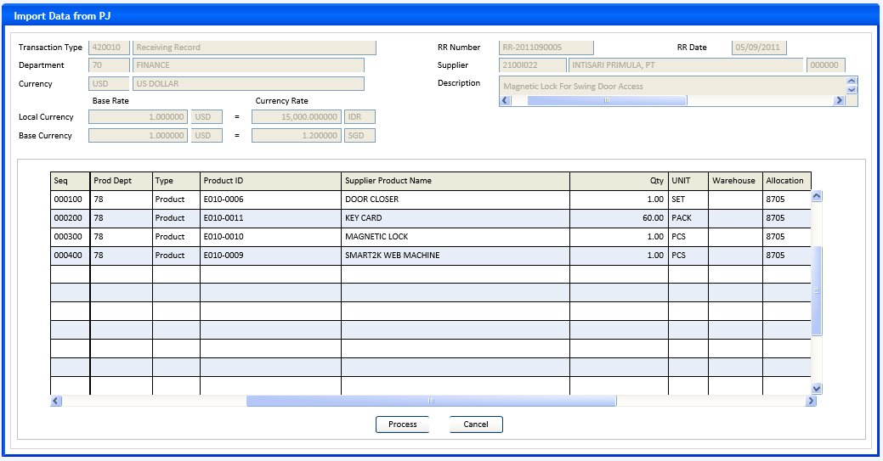

INITIAL PROCESS
Form 3 – Import Data from PJ
- Parameter from calling program: @PCFR_DEPT_CODE, @PCFR_TRANSACTION_CODE, @PCFR_REFERENCE_NO

- Display header fields and grid data

- Go into Normal mode

BUTTON DEFINITION
Form 3 – Import Data from PJ | Test
- Process
- Enabled when there is any active(selected) row in grid.
- Close this form, back to calling form (form 2, page Asset Info}
- Go into Add mode, set some fields default value with fields of grid’s selected row of this form Import Data from PJ
  - @CFR_SEQUENCE_NO = CSEQUENCE_NO
  - {Asset Department code} = CPROD_DEPT_CODE, get and refresh {Asset Department name}
  - {Asset Name} = CSUPP_PRODUCT_NAME
  - {Unit} = CBILL_UNIT
  - {Quantity} = NBILL_UNIT_QTY
  - {Description} = CDETAIL_DESCR
  - {Initial Cost} = NTRANS_AMOUNT
  - {Initial Cost Local Amount} = NLTRANS_AMOUNT
  - {Initial Cost Base Amount} = NBTRANS_AMOUNT

OUTPUT
Form 3 – Import Data from PJ | Test
- None

DISPLAY PROCESS
Form 3 – Import Data from PJ
- Query to fill header fields
SELECT CDEPT_CODE, CTRANSACTION_CODE, CREFERENCE_NO, CTRANSACTION_DATE, CCURRENCY_CODE,
NLBASE_RATE_AMOUNT, NLCURRENCY_RATE_AMOUNT, NBBASE_RATE_AMOUNT, NBCURRENCY_RATE_AMOUNT,
CTRANSACTION_DESCR, CSUPPLIER_ID, CINFO_SEQNO,
CDEPT_NAME = ISNULL(b.DESCRIPTION,’’),
CCURRENCY_NAME = ISNULL(CCURRENCY_NAME,’’),
CTRANSACTION_NAME = ISNULL(CTRANSACTION_NAME,’’),
CSUPPLIER_NAME = ISNULL(CSUPPLIER_NAME,’’)
FROM PJT_TRANSACTION_HD a (nolock)
LEFT JOIN RFT_GET_GSB_CODE_INFO(‘RHAPSODY’, {login_company_id}, ’_DEPARTMENT’,’’,
{login language id}) b ON b.CODE = a.CDEPT_CODE
LEFT JOIN SAB_CURRENCY c (nolock) ON c.CCURRENCY_CODE = a.CCURRENCY_CODE
LEFT JOIN GSM_TRANSACTION_CODE d (nolock) ON d.CCOMPANY_ID=a.CCOMPANY_ID and
d.CTRANSACTION_CODE=a.CTRANSACTION_CODE
LEFT JOIN GSM_SUPPLIER e (nolock) ON e.CCOMPANY_ID=a.CCOMPANY_ID and e.CSUPPLIER_ID=a.CSUPPLIER_ID
WHERE a.CCOMPANY_ID={login_company_id} AND a.DEPT_CODE={@PCFR_DEPT_CODE} AND a.CTRANSACTION_CODE =
{@PCFR_TRANSACTION_CODE} AND a.CREFERENCE_NO=@PCFR_REFERENCE_NO

    - FIELD DEFINITION
All fields are read only
  - Transaction Type code
    - Field : CTRANSACTION_CODE varchar(6)

  - Transaction Type description
    - Field : CTRANSACTION_NAME nvarchar(60)

  - RR Number
    - Field : CREFERENCE_NO varchar(30)

  - RR Date
    - Field : CTRANSACTION_DATE char(8) display with date format
  - Department code
    - Field : CDEPT_CODE varchar(8)

  - Department name
    - Field : CDEPT_NAME nvarchar(60)

  - Supplier code
    - Field : CSUPPLIER_ID varchar(10)

  - Supplier name
    - Field : CSUPPLIER_NAME nvarchar(60)
  - Supplier sequence
    - Field : CINFO_SEQNO varchar(6)
  - Currency code
    - Field : CCURRENCY_CODE varchar(3)

  - Currency name
    - Field : CCURRENCY_NAME nvarchar(60)

  - Description
    - Field : CTRANSACTION_DESCR nvarchar(200)

  - Local Currency – Base Rate – currency code
    - Field : CCURRENCY_CODE varchar(3)

  - Local Currency – Base Rate – amount
    - Field : NLBASE_RATE_AMOUNT numeric 6 decimal

  - Local Currency – Currency Rate – currency code
    - Field : @CLOCAL_CURRENCY_CODE varchar(3)

  - Local Currency – Currency Rate – amount
    - Field : NLCURRENCY_RATE_AMOUNT numeric 6 decimal

  - Base Currency – Base Rate – currency code
    - Field : CCURRENCY_CODE varchar(3)

  - Base Currency – Base Rate – amount
    - Field : NBBASE_RATE_AMOUNT numeric 6 decimal

  - Base Currency – Currency Rate – currency code
    - Field : @CBASE_CURRENCY_CODE varchar(3)

  - Base Currency – Currency Rate – amount
    - Field : NBCURRENCY_RATE_AMOUNT numeric 6 decimal

- Query to fill grid fields
SELECT CSEQUENCE_NO, CPROD_DEPT_CODE, IPRODTYP, CPRODUCT_ID, CSUPP_PRODUCT_NAME, --CR15
a.CALLOC_EXPENSE_CODE, CWAREHOUSE_ID, CBILL_UNIT, NBILL_UNIT_QTY,
CPRODTYP_DESC = case IPRODTYP when 1 then ’Product’ else ’Expenditure’ end,
CDETAIL_DESCR, NTRANS_AMOUNT, NLTRANS_AMOUNT, NBTRANS_AMOUNT --CR10
FROM PJT_TRANSACTION_DT a (nolock)
LEFT JOIN FAT_TRANS_ASSET b (nolock) on b.CCOMPANY_ID=a.CCOMPANY_ID and b.CFR_DEPT_CODE=a.CDEPT_CODE
and b.CFR_TRANSACTION_CODE=a.CTRANSACTION_CODE and b.CFR_REFERENCE_NO=a.CREFERENCE_NO and
and b.CFR_SEQUENCE_NO=a.CSEQUENCE_NO and b.LDELETE_FLAG=0
WHERE a.CCOMPANY_ID={login_company_id} AND a.CDEPT_CODE={@PCFR_DEPT_CODE} AND a.CTRANSACTION_CODE =
{@PCFR_TRANSACTION_CODE} AND a.CREFERENCE_NO=@PCFR_REFERENCE_NO and CSTATUS=’08’
and a.CALLOC_EXPENSE_CODE<>’’ and b.CCOMPANY_ID is null --CR16
    - GRID COLUMNS DEFINITION
All columns are read only

  - Seq
    - Field : CSEQUENCE_NO varchar(6)

  - Prod Dept
    - Field : CPROD_DEPT_CODE varchar(8)

  - Type
    - Field : CPRODTYP_DESC nvarchar(12)

  - Product ID
    - Field : CPRODUCT_ID varchar(20)

  - Supplier Product Name
    - Field : CSUPP_PRODUCT_NAME nvarchar(60)

  - Qty
    - Field : NBILL_UNIT_QTY integer

  - Unit
    - Field : CBILL_UNIT varchar(6)

  - Warehouse
    - Field : CWAREHOUSE_ID varchar(8)

  - Allocation
    - Field : CALLOC_EXPENSE_CODE varchar(8)

Form 4 : Import Existing Asset from Excel -- CR14 --CR21
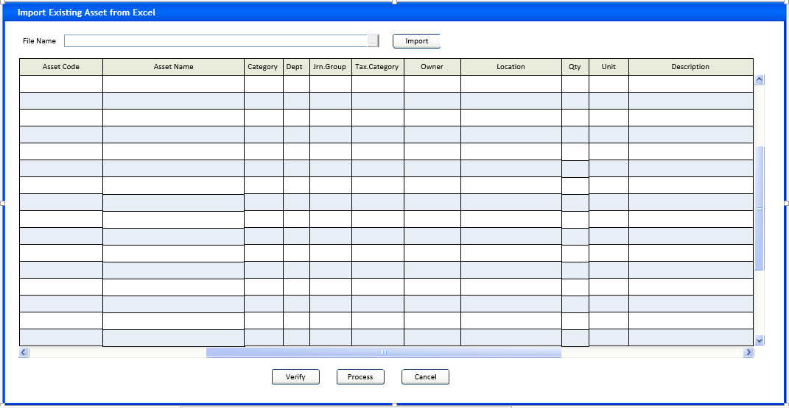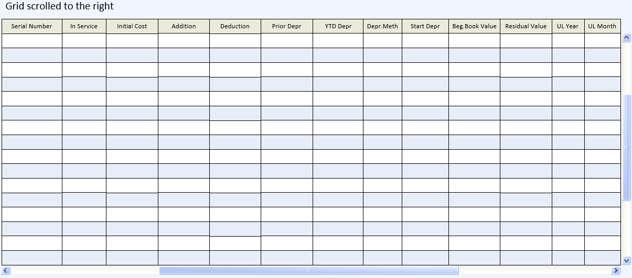

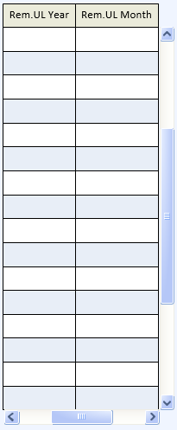

INITIAL PROCESS --CR14
Form 4 : Import Existing Asset from Excel
- Parameter from calling program: @PCDEPT_CODE, @PCTRANSACTION_CODE, @PCREFERENCE_NO,
@PLASSET_INCREMENT_FLAG
- Go into Normal mode

BUTTON DEFINITION --CR14
Form 4 : Import Existing Asset from Excel | Test
  - File Name lookup
    - A file explorer function button
    - Always enabled
    - Explore for Excel files
  - Import
    - Enabled when {File Name} changed and {File Name} <> ’’
    - Validate {File Name} is an Excel file with valid format (columns configuration, etc, see Excel File Format Layout )
* Message : Please select a valid formatted Excel file
    - If the grid not empty
then confirm : Discard existing imported data ? Yes/No
If No then do nothing and back to form
If Yes then delete all data in the grid
    - Read the Excel file content and save to cursor table ExcelData with fields :

    - CASSET_CODE Varchar(20)
    - CASSET_NAME Nvarchar(60)
    - CCATEGORY_CODE Varchar(6)
    - CASSET_DEPT_CODE Varchar(8)
    - CJRNGRP_CODE Varchar(5)
    - CTAX_CATEGORY_CODE Varchar(8)
    - CASSET_OWNER Nvarchar(30)
    - CASSET_LOCATION Nvarchar(60)
    - IBEGINNING_QTY Integer
    - CUNIT Varchar(6)
    - CTRANS_DESCRIPTION Nvarchar(300)
    - CSERIAL_NUMBER Varchar(20)
    - CINSERVICE_DATE Varchar(8)
    - NBEGINNING_AMT Numeric(18,2)
    - NLADDITION_AMT Numeric(18,2)
    - NLDEDUCTION_AMT Numeric(18,2)
    - NLPRIOR_DEPR_AMT Numeric(18,2)
    - NLYTD_DEPR_AMT Numeric(18,2)
    - CDEPR_METHOD Char(1)
    - CSTART_DATE Varchar(8)
    - NLBEG_BOOK_VALUE Numeric(18,2) --CR21
    - NLRESIDUAL_VALUE Numeric(18,2)
    - IUSEFUL_LIVE_YR Integer
    - IUSEFUL_LIVE_MO Integer
    - IREM_USEFUL_LIVE_YR Integer --CR21
    - IREM_USEFUL_LIVE_MO Integer --CR21

    - Refresh grid rows with data from cursor table ExcelData
    - Disable button Import itself
  - Verify
    - Enabled when the grid has data
    - Copy grid rows to SQL temporary table #ExAsset
    - Do RSP_FAT00100_VALIDATE_IMPORTED_ASSET with parameter : {login_company_id}, @PCDEPT_CODE, @PCTRANSACTION_CODE, @PCREFERENCE_NO
This SP will return Number of Error, If 0 (zero) then message : All asset data is valid and ready for processing.
    - Back to form
  - Process
    - Enabled when the grid has data
    - Copy grid rows to SQL temporary table #ExAsset (with similar fields schema to cursor table ExcelData)
    - Do RSP_FAT00100_VALIDATE_IMPORTED_ASSET with parameter : {login_company_id}, @PCDEPT_CODE, @PCTRANSACTION_CODE, @PCREFERENCE_NO
This SP will return Number of Error, if not 0 (zero) then do nothing, back to form.
    - If @PLASSET_INCREMENT_FLAG=1 and there is any grid data with {Asset Code}=’’
then warning : System will generate Asset Code for data with empty one
    - Confirmation : Are you sure to continue processing ? (Yes/No)
If No then do nothing, back to form
    - Message : Please wait, creating asset data in progress …
    - Do RSP_FAT00100_SAVE_IMPORTED_ASSET with parameter : {login_company_id}, @PCDEPT_CODE, @PCTRANSACTION_CODE, @PCREFERENCE_NO, {login_user_id} Asynchronous process
    - Message : Pocessing done
    - Clear the grid
    - {File Name} = ’’, disable Import button, back to form
  - Cancel
    - Enabled when the grid has data
    - Clear the grid
    - Disable Process button
    - Set {File Name} = ’’, disable Import button, back to form

OUTPUT --CR14
Form 4 : Import Existing Asset from Excel | Test
- None

DISPLAY PROCESS --CR14
Form 4 : Import Existing Asset from Excel
- File Name
  - Field : @CFILE_NAME varchar(100)
  - Always enabled
  - If value changed and {File Name} <> ’’ then enable button Import

    - Query Cursor Table ExcelData to fill Grid --CR21
SELECT CASSET_CODE, CASSET_NAME, CCATEGORY_CODE, CASSET_DEPT_CODE, CJRNGRP_CODE, CTAX_CATEGORY_CODE,
CASSET_OWNER, CASSET_LOCATION, IBEGINNING_QTY, CUNIT, CTRANS_DESCRIPTION, CSERIAL_NUMBER,
CINSERVICE_DATE,NBEGINNING_AMT, NLADDITION_AMT, NLDEDUCTION_AMT, NLPRIOR_DEPR_AMT, NLYTD_DEPR_AMT,
CDEPR_METHOD, CSTART_DATE, NLBEG_BOOK_VALUE, NLRESIDUAL_VALUE, IUSEFUL_LIVE_YR, IUSEFUL_LIVE_MO,
IREM_USEFUL_LIVE_YR, IREM_USEFUL_LIVE_MO
FROM {Cursor Table ExcelData}

    - GRID COLUMNS DEFINITION
All columns are read only
  - Asset Code
    - Field : CASSET_CODE varchar(20)

  - Asset Name
    - Field : CASSET_NAME nvarchar(60)

  - Category
    - Field : CCATEGORY_CODE varchar(6)

  - Dept
    - Field : CASSET_DEPT_CODE varchar(8)

  - Jrn Group
    - Field : CJRNGRP_CODE varchar(5)

  - Tax Category
    - Field : CTAX_CATEGORY_CODE varchar(8)

  - Owner
    - Field : CASSET_OWNER nvarchar(30)

  - Location
    - Field : CASSET_LOCATION nvarchar(60)

  - Qty
    - Field : IBEGINNING_QTY integer

  - Unit
    - Field : CUNIT varchar(6)

  - Description
    - Field : CTRANSACTION_DESCR nvarchar(300)

  - Serial Number
    - Field : CSERIAL_NUMBER varchar(30)
  - In Service
    - Field : CINSERVICE_DATE varchar(8) use date format

  - Initial Cost
    - Field : NLBEGINNING_AMT numeric 2 decimal

  - Addition
    - Field : NLADDITION_AMT numeric 2 decimal

  - Deduction
    - Field : NLDEDUCTION_AMT numeric 2 decimal

  - Prior Depr
    - Field : NLPRIOR_DEPR_AMT numeric 2 decimal

  - YTD Depr
    - Field : NLYTD_DEPR_AMT numeric 2 decimal

  - Depr Meth
    - Field : CDEPR_METHOD char(1)
  - Start Depr
    - Field : CSTART_DATE varchar(8), display with date format

  - Beg.Book Value --CR21
    - Field : NLBEG_BOOK_VALUE numeric 2 decimal
  - Residual Value
    - Field : NLRESIDUAL_VALUE numeric 2 decimal

  - UL Yr
    - Field : IUSEFUL_LIVE_YR smallint

  - UL Mo
    - Field : IUSEFUL_LIVE_MO smallint

  - Rem.UL Yr --CR21
    - Field : IREM_USEFUL_LIVE_YR smallint

  - Rem.UL Mo --CR21
    - Field : IREM_USEFUL_LIVE_MO smallint

Excel File Format Layout --CR14 --CR21
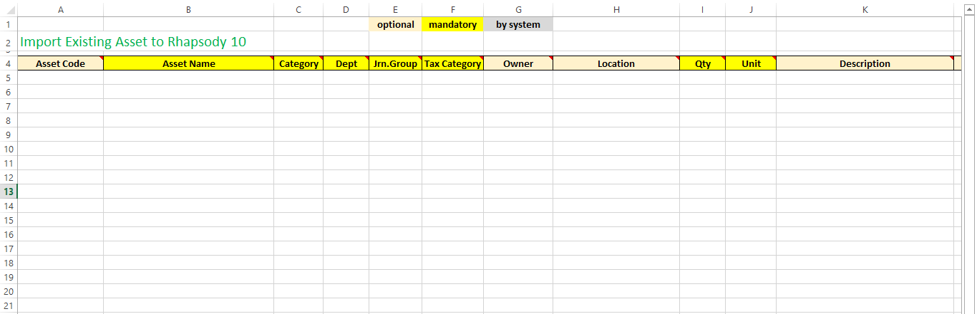
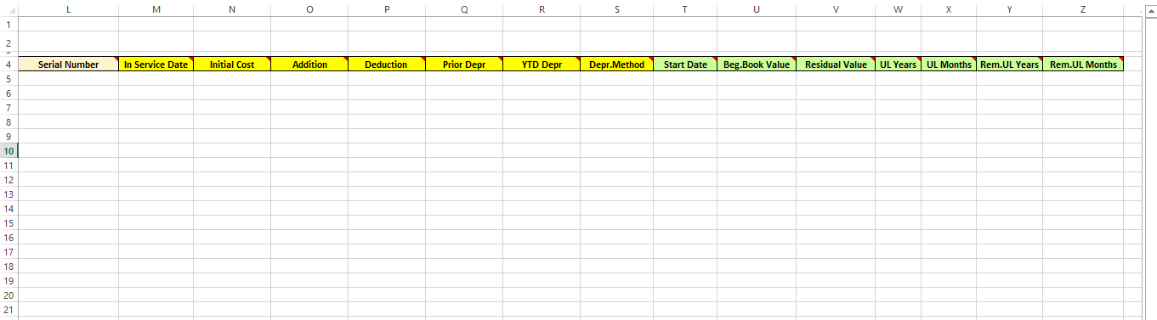

RSP_FAT00100_SAVE_IMPORTED_ASSET --CR14
Test
Parameter : @PCCOMPANY_ID, @PCDEPT_CODE, @PCTRANSACTION_CODE, @PCREFERENCE_NO, @PCUSER_ID
SELECT @CTRANSACTION_DATE, @CTRANSACTION_PRD, @CDOCUMENT_DATE
@NLBASE_RATE_AMOUNT, @NLCURRENCY_RATE_AMOUNT
@NBBASE_RATE_AMOUNT, @NBCURRENCY_RATE_AMOUNT
@NLRATE = ROUND(NLCURRENCY_RATE_AMOUNT / NLBASE_RATE_AMOUNT, 6),
@NBRATE = ROUND(NBCURRENCY_RATE_AMOUNT / NBBASE_RATE_AMOUNT, 6),
@NBXRATE = ROUND((NBCURRENCY_RATE_AMOUNT * NLBASE_RATE_AMOUNT)/
(NLCURRENCY_RATE_AMOUNT * NBBASE_RATE_AMOUNT), 6)
FROM FAT_TRANS_HD (nolock)
WHERE CCOMPANY_ID=@PCCOMPANY_ID and CDEPT_CODE=@PCDEPT_CODE and CTRANSACTION_CODE=@PCTRANSACTION_CODE and
CREFERENCE_NO=@PCREFERENCE_NO
SELECT @ILAST_SEQNO = CONVERT(INTEGER, MAX(CTRANS_SEQNO))
FROM FAT_TRANS_ASSET (nolock)
WHERE CCOMPANY_ID=@PCCOMPANY_ID and CDEPT_CODE=@PCDEPT_CODE and CTRANSACTION_CODE=@PCTRANSACTION_CODE and
CREFERENCE_NO=@PCREFERENCE_NO

@CCURRENT_DTTM = {property date/time}
Create cursor c_Asset --CR21
Select CASSET_CODE, CASSET_NAME, CCATEGORY_CODE, CASSET_DEPT_CODE, CJRNGRP_CODE, CTAX_CATEGORY_CODE,
CASSET_OWNER, CASSET_LOCATION, IBEGINNING_QTY, CUNIT, CTRANS_DESCRIPTION, CSERIAL_NUMBER,
CINSERVICE_DATE,NBEGINNING_AMT, NLADDITION_AMT, NLDEDUCTION_AMT, NLPRIOR_DEPR_AMT, NLYTD_DEPR_AMT,
CDEPR_METHOD, CSTART_DATE, NLBEG_BOOK_VALUE, NLRESIDUAL_VALUE, IUSEFUL_LIVE_YR, IUSEFUL_LIVE_MO,
IREM_USEFUL_LIVE_YR, IREM_USEFUL_LIVE_MO
from #ExAsset

Scan cursor c_Asset
BEGIN TRAN
  - Get Asset Code
If @CASSET_CODE = ’’ then Run RSP_FA_GET_ASSET_CODE parameter :
    - @PCCOMPANY_ID
    - @CASSET_DEPT_CODE
    - @CJRNGRP_CODE
    - @CTRANSACTION_DATE
    - @PCUSER_ID
    - @CASSET_CODE output

  - Get Transaction Sequence Number
@ILAST_SEQNO = @ILAST_SEQNO + 100
@CTRANS_SEQNO = right(’000000’ + convert(varchar(6), @ILAST_SEQNO),6)

  - Add Data Into FAT_TRANS_ASSET

    - CCOMPANY_ID = @PCCOMPANY_ID
    - CDEPT_CODE = @PCDEPT_CODE
    - CTRANSACTION_CODE = @PCTRANSACTION_CODE
    - CREFERENCE_NO = @PCREFERENCE_NO
    - CASSET_CODE = @CASSET_CODE
    - CTRANS_SEQNO = @CTRANS_SEQNO
    - CASSET_TRANS_SEQNO = ’000100’ --CR22
    - CTRANSACTION_DATE = @CTRANSACTION_DATE
    - NBBASE_RATE_AMOUNT ignored
    - NBCURRENCY_RATE_AMOUNT ignored
    - NTRANSACTION_AMOUNT1 = @NBEGINNING_AMT
    - NTRANSACTION_AMOUNT2 ignored
    - NTRANSACTION_AMOUNT3 ignored
    - NTRANSACTION_AMOUNT4 ignored
    - NTRANSACTION_AMOUNT5 ignored
    - NTRANSACTION_AMOUNT6 ignored
    - NLTRANSACTION_AMOUNT1 = ROUND(@NLRATE * @NBEGINNING_AMT, 2)
    - NLTRANSACTION_AMOUNT2 = @NLADDITION_AMT
    - NLTRANSACTION_AMOUNT3 = @NLDEDUCTION_AMT
    - NLTRANSACTION_AMOUNT4 = @NLPRIOR_DEPR_AMT
    - NLTRANSACTION_AMOUNT5 = @NLYTD_DEPR_AMT
    - NLTRANSACTION_AMOUNT6 ignored
    - NBTRANSACTION_AMOUNT1 = ROUND(@NBRATE * @NBEGINNING_AMT, 2)
    - NBTRANSACTION_AMOUNT2 = ROUND(@NBXRATE} * @NLADDITION_AMT, 2)
    - NBTRANSACTION_AMOUNT3 = ROUND(@NBXRATE} * @NLDEDUCTION_AMT, 2)
    - NBTRANSACTION_AMOUNT4 = ROUND(@NBXRATE} * @NLPRIOR_DEPR_AMT, 2)
    - NBTRANSACTION_AMOUNT5 = ROUND(@NBXRATE} * @NLYTD_DEPR_AMT, 2)
    - NBTRANSACTION_AMOUNT6 ignored
    - ITRANSACTION_QTY1 = @IBEGINNING_QTY
    - ITRANSACTION_QTY2 ignored
    - CUNIT = @CUNIT
    - CALLOC_EXPENSE_CODE ignored
    - CFR_DEPT_CODE ignored
    - CFR_TRANSACTION_CODE ignored
    - CFR_REFERENCE_NO ignored
    - CFR_TRANSACTION_DATE ignored
    - CFR_SEQUENCE_NO ignored
    - CTRANSACTION_DESCR = @CTRANS_DESCRIPTION
    - CASSET_DEPT_CODE = @CASSET_DEPT_CODE
    - CASSET_LOCATION = @CASSET_LOCATION
    - CJRNGRP_CODE = @CJRNGRP_CODE
    - CTAX_CATEGORY_CODE = @CTAX_CATEGORY_CODE
    - CCATEGORY_CODE = @CCATEGORY_CODE
    - CSCATEGORY_CODE ignored
    - CDEPR_METHOD = @CDEPR_METHOD
    - CSTART_DATE = if @CDEPR_METHOD<>’0’ then @CSTART_DATE else ’’
    - NLBOOK_VALUE = ROUND(@NLRATE * @NBEGINNING_AMT, 2) + @NLADDITION_AMT - @NLDEDUCTION_AMT
- @NLPRIOR_DEPR_AMT - @NLYTD_DEPR_AMT
    - NBBOOK_VALUE = ROUND(@NBRATE * @NBEGINNING_AMT, 2)
+ ROUND(@NBXRATE} * @NLADDITION_AMT, 2)
- ROUND(@NBXRATE} * @NLDEDUCTION_AMT, 2)
- ROUND(@NBXRATE} * @NLPRIOR_DEPR_AMT, 2)
- ROUND(@NBXRATE} * @NLYTD_DEPR_AMT, 2)
    - IUSEFUL_LIVE = if @CDEPR_METHOD<>’0’ then (@IREM_USEFUL_LIVE_YR * 12) + @IREM_USEFUL_LIVE_MO
else 0 --CR21
    - NLYEAR_DEPR_AMT = if @CDEPR_METHOD not in(’0’,’9’) then ROUND((ROUND(@NLRATE * @NBEGINNING_AMT, 2) + @NLADDITION_AMT - @NLDEDUCTION_AMT - @NLPRIOR_DEPR_AMT - @NLYTD_DEPR_AMT
@NLBEG_BOOK_VALUE – iif(@CDEPR_METHOD=’1’, @NLRESIDUAL_VALUE, 0)) / (((@IUSEFUL_LIVE_YR * 12) + @IUSEFUL_LIVE_MO) / 12.00000000), 2) * iif(@CDEPR_METHOD=’3’,2,1) else 0.00 --CR17 --CR21 –CR23
    - NBYEAR_DEPR_AMT = if @CDEPR_METHOD not in(’0’,’9’) then ROUND((ROUND(@NBRATE * @NBEGINNING_AMT, 2) + ROUND(@NBXRATE * @NLADDITION_AMT, 2) – ROUND(@NBXRATE * @NLDEDUCTION_AMT, 2) – ROUND(@NBXRATE * @NLPRIOR_DEPR_AMT, 2) – ROUND(@NBXRATE * @NLYTD_DEPR_AMT, 2)
ROUND(@NBXRATE * @NLBEG_BOOK_VALUE, 2) – iif(@CDEPR_METHOD=’1’, ROUND(@NBXRATE * @NLRESIDUAL_VALUE, 2), 0)) / (((@IUSEFUL_LIVE_YR * 12) + @IUSEFUL_LIVE_MO) / 12.00000000), 2) * iif(@CDEPR_METHOD=’3’,2,1) else 0.00 --CR17 --CR21 –CR23

    - NLRESIDUAL_VALUE = if @CDEPR_METHOD<>’0’ then @NLRESIDUAL_VALUE else 0.00 --CR17
    - NBRESIDUAL_VALUE = if @CDEPR_METHOD<>’0’ then ROUND(@NBXRATE} * @NLRESIDUAL_VALUE, 2)
else 0.00 --CR17
    - NYEAR_DEPR_PCT = if @CDEPR_METHOD not in(’0’,’9’) then ROUND((if @CDEPR_METHOD=’3’ then 200 else 100) / (((@IUSEFUL_LIVE_YR * 12) + @IUSEFUL_LIVE_MO) / 12.00000000), 2) else 0.00 --CR17 –CR23
    - COASSET_DEPT_CODE ignored
    - COASSET_LOCATION ignored
    - COJRNGRP_CODE ignored
    - COTAX_CATEGORY_CODE ignored
    - COCATEGORY_CODE ignored
    - COSCATEGORY_CODE ignored
    - CODEPR_METHOD ignored
    - COSTART_DATE ignored
    - NOLBOOK_VALUE = @NLBEG_BOOK_VALUE --CR21
    - NOBBOOK_VALUE = ROUND(@NBXRATE * @NLBEG_BOOK_VALUE, 2) --CR21
    - IOUSEFUL_LIVE = if @CDEPR_METHOD<>’0’ then (@IUSEFUL_LIVE_YR * 12) + @IUSEFUL_LIVE_MO
else 0 --CR21
    - NOLYEAR_DEPR_AMT ignored
    - NOBYEAR_DEPR_AMT ignored
    - NOLRESIDUAL_VALUE ignored
    - NOBRESIDUAL_VALUE ignored
    - NOYEAR_DEPR_PCT ignored
    - IOTRANSACTION_QTY1 ignored
    - LDELETE_FLAG = 0
    - CDEPR_STATUS = if @NLPRIOR_DEPR_AMT<>0.00 or @NLYTD_DEPR_AMT<>0.00 then ’1’ else ’0’
    - CCURRENT_PRD = @CTRANSACTION_PRD
    - CLLINK_FLAG ignored
    - CCREATE_BY = @PCUSER_ID
    - DCREATE_DATE = @CCURRENT_DTTM
    - CUPDATE_BY = @PCUSER_ID
    - DUPDATE_DATE = @CCURRENT_DTTM

  - Add Data Into FAM_ASSET
    - CCOMPANY_ID = @PCCOMPANY_ID
    - CASSET_CODE = @CASSET_CODE
    - CASSET_NAME = @CASSET_NAME
    - CSERIAL_NUMBER = @CSERIAL_NUMBER
    - CTRANS_DESCRIPTION = @CTRANS_DESCRIPTION
    - CINSERVICE_DATE = @CINSERVICE_DATE
    - CASSET_DEPT_CODE = @CASSET_DEPT_CODE
    - CASSET_OWNER = @CASSET_OWNER
    - CASSET_LOCATION = @CASSET_LOCATION
    - CJRNGRP_CODE = @CJRNGRP_CODE
    - CTAX_CATEGORY_CODE = @CTAX_CATEGORY_CODE
    - CCATEGORY_CODE = @CCATEGORY_CODE
    - CSCATEGORY_CODE ignored
    - CDEPR_METHOD = @CDEPR_METHOD
    - CSTART_DATE = if @CDEPR_METHOD<>’0’ then @CSTART_DATE else ’’
    - NLBOOK_VALUE = ROUND(@NLRATE * @NBEGINNING_AMT, 2) + @NLADDITION_AMT - @NLDEDUCTION_AMT
- @NLPRIOR_DEPR_AMT - @NLYTD_DEPR_AMT
    - NBBOOK_VALUE = ROUND(@NBRATE * @NBEGINNING_AMT, 2)
+ ROUND(@NBXRATE} * @NLADDITION_AMT, 2)
- ROUND(@NBXRATE} * @NLDEDUCTION_AMT, 2)
- ROUND(@NBXRATE} * @NLPRIOR_DEPR_AMT, 2)
- ROUND(@NBXRATE} * @NLYTD_DEPR_AMT, 2)
    - IUSEFUL_LIVE = if @CDEPR_METHOD<>’0’ then (@IREM_USEFUL_LIVE_YR * 12) + @IREM_USEFUL_LIVE_MO
else 0 --CR21

    - NYEAR_DEPR_PCT = if @CDEPR_METHOD not in(’0’,’9’) then ROUND((if @CDEPR_METHOD=’3’ then 200 else 100) / (((@IUSEFUL_LIVE_YR * 12) + @IUSEFUL_LIVE_MO) / 12.00000000), 2) else 0.00 --CR17 --CR23
    - NLYEAR_DEPR_AMT = if @CDEPR_METHOD not in(’0’,’9’) then ROUND((ROUND(@NLRATE * @NBEGINNING_AMT, 2) + @NLADDITION_AMT - @NLDEDUCTION_AMT - @NLPRIOR_DEPR_AMT - @NLYTD_DEPR_AMT @NLBEG_BOOK_VALUE – iif(@CDEPR_METHOD=’1’, @NLRESIDUAL_VALUE, 0)) / (((@IUSEFUL_LIVE_YR * 12) + @IUSEFUL_LIVE_MO) / 12), 2) * iif(@CDEPR_METHOD=’3’,2,1) else 0.00 --CR17 --CR21
    - NBYEAR_DEPR_AMT = if @CDEPR_METHOD not in(’0’,’9’) then (ROUND((ROUND(@NBRATE * @NBEGINNING_AMT, 2) + ROUND(@NBXRATE * @NLADDITION_AMT, 2) – ROUND(@NBXRATE * @NLDEDUCTION_AMT, 2) – ROUND(@NBXRATE * @NLPRIOR_DEPR_AMT, 2) – ROUND(@NBXRATE * @NLYTD_DEPR_AMT, 2)
ROUND(@NBXRATE * @NLBEG_BOOK_VALUE, 2) – iif(@CDEPR_METHOD=’1’, ROUND(@NBXRATE * @NLRESIDUAL_VALUE, 2), 0)) / (((@IUSEFUL_LIVE_YR * 12) + @IUSEFUL_LIVE_MO) / 12.00000000), 2) * iif(@CDEPR_METHOD=’3’,2,1) else 0.00 --CR17 --CR21 --CR23

    - NLRESIDUAL_VALUE = if @CDEPR_METHOD<>’0’ then @NLRESIDUAL_VALUE else 0.00 --CR17
    - NBRESIDUAL_VALUE = if @CDEPR_METHOD<>’0’ then ROUND(@NBXRATE} * @NLRESIDUAL_VALUE, 2)
else 0.00 --CR17
    - NLYTD_DEPR_AMT = @NLYTD_DEPR_AMT
    - NBYTD_DEPR_AMT = ROUND(@NBXRATE} * @NLYTD_DEPR_AMT, 2)
    - LNEW_FLAG = 0
    - CUNIT = @CUNIT
    - CPURCHASE_DATE = if @CDOCUMENT_DATE<>’’ then @CDOCUMENT_DATE else @CTRANSACTION_DATE
    - CSUPPLIER_ID ignored
    - CSUPPLIER_NAME ignored
    - NLBEG_BOOK_VALUE = ROUND(@NLRATE * @NBEGINNING_AMT, 2) + @NLADDITION_AMT - @NLDEDUCTION_AMT
- @NLPRIOR_DEPR_AMT - @NLYTD_DEPR_AMT @NLBEG_BOOK_VALUE --CR21

    - NBBEG_BOOK_VALUE = ROUND(@NBRATE * @NBEGINNING_AMT, 2)
+ ROUND(@NBXRATE} * @NLADDITION_AMT, 2)
- ROUND(@NBXRATE} * @NLDEDUCTION_AMT, 2)
- ROUND(@NBXRATE} * @NLPRIOR_DEPR_AMT, 2)
- ROUND(@NBXRATE} * @NLYTD_DEPR_AMT, 2)
ROUND(@NBXRATE * @NLBEG_BOOK_VALUE, 2) --CR21
    - IBEG_USEFUL_LIVE = if @CDEPR_METHOD<>’0’ then (@IUSEFUL_LIVE_YR * 12) + @IUSEFUL_LIVE_MO else 0
--CR17
    - NLBEGINNING_AMT = ROUND(@NLRATE * @NBEGINNING_AMT, 2)
    - NBBEGINNING_AMT = ROUND(@NBRATE * @NBEGINNING_AMT, 2)
    - NLADDITION_AMT = @NLADDITION_AMT
    - NBADDITION_AMT = ROUND(@NBXRATE * @NLADDITION_AMT, 2)
    - NLDEDUCTION_AMT = @NLDEDUCTION_AMT
    - NBDEDUCTION_AMT = ROUND(@NBXRATE * @NLDEDUCTION_AMT, 2)
    - NLREVENUE_AMT = 0.00
    - NBREVENUE_AMT = 0.00
    - NLSOLD_AMT = 0.00
    - NBSOLD_AMT = 0.00
    - IBEGINNING_Qty = @IBEGINNING_QTY
    - IADDITION_QTY = 0
    - IDEDUCTION_QTY = 0
    - NLPRIOR_DEPR_AMT = @NLPRIOR_DEPR_AMT
    - NBPRIOR_DEPR_AMT = ROUND(@NBXRATE * @NLPRIOR_DEPR_AMT, 2)
    - NLREVALUATION_AMT = 0.00
    - NBREVALUATION_AMT = 0.00
    - NLPRIOR_REVALUATION_AMT = 0.00
    - NBPRIOR_REVALUATION_AMT = 0.00
    - NLYTD_REVALUATION_AMT = 0.00
    - NBYTD_REVALUATION_AMT = 0.00
    - CLSEQUENCE_NO = ’000100’
    - CLAST_TRANS_DATE = @CTRANSACTION_DATE
    - CLAST_DEPR_PERIOD = ’’
    - CASSET_STATUS = ’0’
    - OASSET_IMAGE ignored
    - CFR_DEPT_CODE ignored
    - CFR_TRANSACTION_CODE ignored
    - CFR_REFERENCE_NO ignored
    - CFR_TRANSACTION_DATE ignored
    - CFR_SEQUENCE_NO ignored
    - NLAST_BBASE_RATE_AMOUNT = if @NLBASE_RATE_AMOUNT * @NBCURRENCY_RATE_AMOUNT >
@NBBASE_RATE_AMOUNT * @NLCURRENCY_RATE_AMOUNT then ROUND((@NLBASE_RATE_AMOUNT * @NBCURRENCY_RATE_AMOUNT ) / (@NBBASE_RATE_AMOUNT * @NLCURRENCY_RATE_AMOUNT), 6) else 1.000000
    - NLAST_BCURRENCY_RATE_AMOUNT = if @NLBASE_RATE_AMOUNT * @NBCURRENCY_RATE_AMOUNT >
@NBBASE_RATE_AMOUNT * @NLCURRENCY_RATE_AMOUNT then 1.000000 else ROUND((@NBBASE_RATE_AMOUNT * @NLCURRENCY_RATE_AMOUNT) / (@NLBASE_RATE_AMOUNT * @NBCURRENCY_RATE_AMOUNT), 6)
    - CLAST_CURR_RATE_DATE = @CTRANSACTION_DATE
    - NBRATE_REVALUATION_AMT = 0.00
    - CCREATE_BY = @PCUSER_ID
    - DCREATE_DATE = @CCURRENT_DTTM
    - CUPDATE_BY = @PCUSER_ID
    - DUPDATE_DATE = @CCURRENT_DTTM

  - Add Data Into FAT_TRANS_EXP_ALLOC
    - CCOMPANY_ID = @PCCOMPANY_ID
    - CDEPT_CODE = @PCDEPT_CODE
    - CTRANSACTION_CODE = @PCTRANSACTION_CODE
    - CREFERENCE_NO = @PCREFERENCE_NO
    - CASSET_CODE = @CASSET_CODE
    - CASSET_TRANS_SEQNO = ’000100’ --CR22
    - CEXPENSE_DEPT_CODE = @CASSET_DEPT_CODE
    - NEXPENSE_PCT = 100.00
    - COLD_FLAG = ’0’
    - CCREATE_BY = @PCUSER_ID
    - DCREATE_DATE = @CCURRENT_DTTM
    - CUPDATE_BY = @PCUSER_ID
    - DUPDATE_DATE = @CCURRENT_DTTM

  - Update FAT_TRANS_HD where CCOMPANY_ID = @PCCOMPANY_ID and CDEPT_CODE = @PCDEPT_CODE and
CTRANSACTION_CODE = @PCTRANSACTION_CODE and CREFERENCE_NO = @PCREFERENCE_NO
    - NTRANSACTION_AMOUNT = NTRANSACTION_AMOUNT + @NBEGINNING_AMT
    - NLTRANSACTION_AMOUNT = NLTRANSACTION_AMOUNT + ROUND(@NLRATE * @NBEGINNING_AMT, 2)
+ @NLADDITION_AMT - @NLDEDUCTION_AMT - @NLPRIOR_DEPR_AMT - @NLYTD_DEPR_AMT
    - NBTRANSACTION_AMOUNT = NBTRANSACTION_AMOUNT + ROUND(@NBRATE * @NBEGINNING_AMT, 2)
+ ROUND(@NBXRATE} * @NLADDITION_AMT, 2)
- ROUND(@NBXRATE} * @NLDEDUCTION_AMT, 2)
- ROUND(@NBXRATE} * @NLPRIOR_DEPR_AMT, 2)
- ROUND(@NBXRATE} * @NLYTD_DEPR_AMT, 2)
COMMIT TRAN
End Scan cursor c_Asset

RSP_FAT00100_VALIDATE_IMPORTED_ASSET --CR14
Test
Parameter : @PCCOMPANY_ID, @PCDEPT_CODE, @PCTRANSACTION_CODE, @PCREFERENCE_NO
SELECT @LASSET_INCREMENT_FLAG = LINCREMENT_FLAG
FROM FAM_SYSTEM (nolock)
WHERE CCOMPANY_ID=@PCCOMPANY_ID
SELECT @CTRANSACTION_DATE, @CDOCUMENT_DATE,
@NLRATE = ROUND(NLCURRENCY_RATE_AMOUNT / NLBASE_RATE_AMOUNT, 6)
FROM FAT_TRANS_HD (nolock)
WHERE CCOMPANY_ID=@PCCOMPANY_ID and CDEPT_CODE=@PCDEPT_CODE and CTRANSACTION_CODE=@PCTRANSACTION_CODE and
CREFERENCE_NO=@PCREFERENCE_NO
CREATE TABLE #ErrorList (ErrCode varchar(6), ErrKey varchar(100))

INSERT INTO #ErrorList SELECT * FROM (

SELECT TOP 1 ErrCode=’Err001’, ErrKey=’’
FROM #ExAsset
WHERE @LASSET_INCREMENT_FLAG=0 and CASSET_CODE=’’
UNION --CR23
SELECT ErrCode=’Err017’, ErrKey=CASSET_CODE
FROM #ExAsset
WHERE CASSET_CODE<>’’
GROUP BY CASSET_CODE
HAVING COUNT(*)>1
UNION
SELECT TOP 1 ErrCode=’Err002’, ErrKey=’’
FROM #ExAsset
WHERE CASSET_NAME=’’ or CCATEGORY_CODE=’’ or CASSET_DEPT_CODE=’’ or CJRNGRP_CODE=’’ or
CTAX_CATEGORY_CODE=’’ or CUNIT=’’ or CINSERVICE_DATE=’’ or CDEPR_METHOD=’’ or
(CDEPR_METHOD<>’0’ and CSTART_DATE=’’)
UNION
SELECT TOP 1 ErrCode=’Err003’, ErrKey=’’
FROM #ExAsset
WHERE IBEGINNING_QTY<0 or NBEGINNING_AMT<0 or NLADDITION_AMT<0 or NLDEDUCTION_AMT<0 or
NLPRIOR_DEPR_AMT<0 or NLYTD_DEPR_AMT<0 or NLRESIDUAL_VALUE<0 or IUSEFUL_LIVE_YR<0 or
IUSEFUL_LIVE_MO<0 or NLBEG_BOOK_VALUE<0 or IREM_USEFUL_LIVE_YR<0 or IREM_USEFUL_LIVE_MO --CR21
UNION
SELECT TOP 1 ErrCode=’Err004’, ErrKey=’’
FROM #ExAsset
WHERE IBEGINNING_QTY=0 or NBEGINNING_AMT=0
UNION
SELECT TOP 1 ErrCode=’Err005’, ErrKey=’’
FROM #ExAsset
WHERE CDEPR_METHOD NOT IN (’0’,’1’,’2’,’3’,’9’) --CR17
UNION
SELECT ErrCode=’Err006’, ErrKey=left(CASSET_NAME,100)
FROM #ExAsset
WHERE ROUND(@NLRATE * NBEGINNING_AMT, 2) + NLADDITION_AMT – NLDEDUCTION_AMT – NLPRIOR_DEPR_AMT
- NLYTD_DEPR_AMT < 0.00
UNION --CR23
SELECT TOP 1 ErrCode=’Err019’, ErrKey=left(CASSET_NAME,100)
FROM #ExAsset
WHERE CDEPR_METHOD<>’0’ and NLBEG_BOOK_VALUE = 0

UNION --CR21
SELECT ErrCode=’Err015’, ErrKey=left(CASSET_NAME,100)
FROM #ExAsset
WHERE CDEPR_METHOD<>’0’ AND NLBEG_BOOK_VALUE < ROUND(@NLRATE * NBEGINNING_AMT, 2) + NLADDITION_AMT –
NLDEDUCTION_AMT – NLPRIOR_DEPR_AMT - NLYTD_DEPR_AMT

UNION --CR21
SELECT ErrCode=’Err016’, ErrKey=left(CASSET_NAME,100)
FROM #ExAsset
WHERE (IREM_USEFUL_LIVE_YR * 12) + IREM_USEFUL_LIVE_MO > (IUSEFUL_LIVE_YR * 12) + IUSEFUL_LIVE_MO
UNION
SELECT ErrCode=’Err007’, ErrKey=left(CASSET_NAME,100)
FROM #ExAsset
WHERE ROUND(@NLRATE * @NBEGINNING_AMT, 2) + NLADDITION_AMT – NLDEDUCTION_AMT – NLPRIOR_DEPR_AMT
- NLYTD_DEPR_AMT NLBEG_BOOK_VALUE < NLRESIDUAL_VALUE --CR21
UNION --CR23
SELECT TOP 1 ErrCode=’Err018’, ErrKey=left(CASSET_NAME,100)
FROM #ExAsset
WHERE CDEPR_METHOD<>’0’ and IUSEFUL_LIVE_YR = 0 and IUSEFUL_LIVE_MO = 0

UNION
SELECT TOP 1 ErrCode=’Err008’, ErrKey=left(CASSET_NAME,100)
FROM #ExAsset
WHERE CDEPR_METHOD<>’0’ and ROUND(@NLRATE * @NBEGINNING_AMT, 2) + NLADDITION_AMT – NLDEDUCTION_AMT
- NLPRIOR_DEPR_AMT – NLYTD_DEPR_AMT – NLRESIDUAL_VALUE > 0 and IREM_USEFUL_LIVE_YR = 0 and
IREM_USEFUL_LIVE_MO = 0 --CR21
UNION --CR17
SELECT TOP 1 ErrCode=’Err009’, ErrKey=left(CASSET_NAME,100)
FROM #ExAsset
WHERE CDEPR_METHOD=’3’ and ROUND(@NLRATE * @NBEGINNING_AMT, 2) + NLADDITION_AMT – NLDEDUCTION_AMT
- NLPRIOR_DEPR_AMT – NLYTD_DEPR_AMT – NLRESIDUAL_VALUE > 0 and IUSEFUL_LIVE_YR < 2 --CR23
UNION
SELECT TOP 1 ErrCode=’Err009’ ’Err010’, ErrKey=left(CASSET_NAME,100) --CR17
FROM #ExAsset
WHERE CDEPR_METHOD<>’0’ (CSTART_DATE < CINSERVICE_DATE or CSTART_DATE < @CTRANSACTION_DATE)
UNION
SELECT ErrCode=’Err011’, ErrKey=left(a.CCATEGORY_CODE,100)
FROM #ExAsset a
LEFT JOIN GSM_CATEGORY s (nolock) ON s.CCOMPANY_ID=@PCCOMPANY_ID and s.CCATEGORY_ITEM=’51’ and
s.CCATEGORY_TYPE=’C’ and s.CCATEGORY_CODE=a.CCATEGORY_CODE
WHERE s.CCOMPANY_ID is null
GROUP BY a.CCATEGORY_CODE
UNION
SELECT ErrCode=’Err012’, ErrKey=left(a.CASSET_DEPT_CODE,100)
FROM #ExAsset a
LEFT JOIN GSM_DEPARTMENT s (nolock) ON s.CCOMPANY_ID=@PCCOMPANY_ID and
s.CDEPT_CODE=a.CASSET_DEPT_CODE
WHERE s.CCOMPANY_ID is null
GROUP BY a.CASSET_DEPT_CODE
UNION
SELECT ErrCode=’Err013’, ErrKey=left(a.CJRNGRP_CODE,100)
FROM #ExAsset a
LEFT JOIN GSM_JRNGRP_HD s (nolock) ON s.CCOMPANY_ID=@PCCOMPANY_ID and s.CJRNGRP_TYPE=’6’ and
s.CJRNGRP_CODE=a.CJRNGRP_CODE
WHERE s.CCOMPANY_ID is null
GROUP BY a.CJRNGRP_CODE
UNION
SELECT ErrCode=’Err014’, ErrKey=left(a.CTAX_CATEGORY_CODE,100)
FROM #ExAsset a
LEFT JOIN FAM_TAX_CATEGORY s (nolock) on s.CCOMPANY_ID=@PCCOMPANY_ID and s.CTAX_CATEGORY_CODE =
a.CTAX_CATEGORY_CODE
WHERE s.CCOMPANY_ID is null
GROUP BY a.CTAX_CATEGORY_CODE
) z

declare c_ErrorList insensitive cursor for
select ErrCode, ErrKey
from #ErrorList
for read only

declare @ErrCount int=0, @ErrCode varchar(6), @ErrKey varchar(100)

open c_ErrorList
fetch next from c_ErrorList into @ErrCode, @ErrKey
while (@@fetch_status=0) begin
exec RSP_Write_Error @@PROCID, @ErrCode, @ErrKey
set @ErrCount=@ErrCount+1
fetch next from c_ErrorList into @ErrCode, @ErrKey
end
close c_ErrorList
deallocate c_ErrorList

drop table #ErrorList

if @ErrCount>0 begin
Raiserror(‘ErrLang’,16,-1)
return @ErrCount
end

return (0)

>> RSP_FAT00100_VALIDATE_IMPORTED_ASSET.txt
Err001 = Asset Code should be not empty
Err002 = All mandatory data should be not empty
Err003 = All numeric data should be not a negative number
Err004 = Quantity and Initial Cost should be not a zero number
Err005 = Depreciation Method code should be 0, 1, 2, 3 or 9 --CR17
Err006 = Current Book Value should be not less than 0.00 --CR21
Err007 = Residual Value should be not greater than Beginning Book Value --CR21
Err008 = Remaining Useful Life should be not a zero number (when asset still be depreciated) --CR21
Err009 = Useful Life should be not less than 2 years for depreciation method Double Declining --CR17
Err009 010 = Start Date should be not before In Service Date and Transaction Date --CR17
Err011 = Category code not valid
Err012 = Department code not valid
Err013 = Journal Group code not valid
Err014 = Tax Category code not valid
Err015 = Beginning Book Value should not less than current Book Value --CR21
Err016 = Remaining Useful Life should not greater than Useful Life --CR21
Err017 = Asset Code should be not duplicated --CR23
Err018 = For depreciated asset, Useful Life should be not a zero number --CR23
Err019 = For depreciated asset, Beginning Book Value should be not a zero number --CR23

APPROVAL_PRECHECK
Test
PARAMETER @CAPPROVAL_CODE

SELECT IAPPVROVAL_OPTION
FROM GSM_ACTIVITY_APPROVAL (NOLOCK)
WHERE CCOMPANY_ID = {login_company_id} AND CAPPROVAL_CODE = @CAPPROVAL_CODE

If found and IAPPVROVAL_OPTION = 2 then return 1 (need approval) else 0 (approval not needed)

App Config

CR LIST
CR | DESCRIPTION | REQUEST BY
8 Apr 2023 | - Initial version
31 May 2023 CR1 | - Little corrections
12 Jul 2023 CR2 | - Add new fields and other correction
27 Jun 2023 CR3 | - Update field currency rate when SAVE TRANSACTION in Edit mode
1 Jul 2023 CR4 | - Transaction date should be in the year of current period
20 Jul 2023 CR5 | - Get description of some code from data query of Asset Information page
25 Jul 2023 CR6 | - Define value of header.NBRATE, NLRATE, NBXRATE
3 Aug 2023 CR7 | - Revise calculation of Yearly Depreciation - %, Local Amount, Base Amount
4 Aug 2023 CR8 | - Revise calculation and dependency of Useful Life year/month and Yearly Depreciation - %
22 Aug 2023 CR9 | - Set default Asset Department code from FA System Parameter
24 Aug 2023 CR10 | - Add Asset only allowed when source is FA  - Submit header transaction not allowed when no asset (detail)  - Add fields in PJ product query needed for new asset default value
29 Aug 2023 CR11 | - Button Delete should be disabled when Cstatus<>’00’  - Validate GL Accounts should be available when transaction closed
12 Sep 2023 CR12 | - Run GSL02000 with parameter ‘6’ instead of ‘1’
22 Sep 2023 CR13 | - Update FAT_TRANS_HD.NTRANSACTION_AMOUNT
27 Oct 2023 CR14 | - Add function Import Existing Asset from Excel
2 Nov 2023 CR15 | - Product/expenditure already imported from PJ should not allowed to be imported again
23 Nov 2023 CR16 | - Only RR Product/expenditure with Allocation Expense code can be pulled out
23 Nov 2023 CR17 | - Add depreciation method Declining and Double Declining
1 Dec 2023 CR18 | - Asset data should be still shown when the header transaction is deleted or voided
18 Dec 2023 CR19 | - Void button should be disabled when transaction already transferred to GL journal
13 May 2024 CR20 | - When call Detail Form (form 2) from button Detail : If transaction has no Asset or only 1 Asset, then set Asset Info page as default active page instead of Asset List page.
18 May 2024 CR21 | - For existing (not New) asset : add input Beginning Book Value and Remaining Useful Life to get a correct Yearly Depreciation Pct and amount
1 Jul 2024 CR22 | - Add Yearly Depreciation Amount calculation for Declining/Double Declining Method of Existing Asset  - Change sequence number from 000001 to 000100
8 May 2025 CR23 | - SP Revision For Imported Asset :  Add Validation duplicate asset code,  Add Validation Useful Life not zero for Depreciated Asset,  Add Validation Beginning Book Value not zero for Depreciated Asset,  Validate UL at Double Declining no need to check Book value,  Fix Rounded issues of Yearly Depreciation Amount/Percentage when saving data
2 Sep 2025 CR24 | - Update FAT_TRANS_HD LGLLINK setiap kali update FAT_TRANS_ASSET antisipasi suppress zero journal

